Booking Flights

SOFTWARE
REQUIREMENT
SPECIFICATION

This documentation describes Software Requirement Specification of Booking Flights, developed by Group 3

Table of Contents
1. Introduction 3
1.1 Research purposes 3
1.2 Research scope 3
1.3 Definition 3
2. Functional Requirements 5
2.1 Functional Requirements list 5
2.2 Use Cases Diagram 7
2.2.1 Notiations 7
2.2.2 System Overview 8
2.2.3 Usecase Search Flights 9
2.2.4 Usecase Booking Flights 11
2.2.5 Usecase Payment Flights 13
2.2.6 Usecase History Booked 16
2.2.7 Usecase Manage Account 18
2.2.8 Usecase Login/Sign Up 24
2.2.9 Manage Airlines 27
2.2.10 Usecase Manage Airports 31
2.2.11 Usecase Manage Flights 34
2.2.12 Usecase Manage Booked Flight 38
2.3 Domain Model 40
2.4 Class Diagram 40
3. Quality Attribute 40
4. Constraints 42
4.1 Business Constraints 42
4.2 Technical Constraint list 42
5. Graphical User Interface Description 43
5.1 SignUp/LogIn Screen: 43
5.2 Search Screen: 47
5.3 Booking Screen: 49
5.4 Payment Screen: 51
5.5 Account Screen: 53
5.6 Booking History Screen: 55
5.7 Admin Screen: 56

Introduction

1.1 Research purposes
The purpose of this project is to provide an airline ticket booking system to meet the increasing demand for travel to many regions of the country and within the country. Therefore, the airport must have a quality, suitable and convenient online ticket booking system for users. The system allows customers when booking airline tickets online to easily select flight dates, choose airlines of their choice and see clearly suitable ticket prices for users to choose, in accordance with their desired requirements of the user.
This document is used as a commitment between the customer and the development team regarding the output product and the regulations of the development process.

The target audience for this document is:

project guide: Dr. Le Hung Tien
project customer: MSE. Dinh Thi Tam
Group 3: project developers

1.2 Research scope
This project aims to streamline the online ticket booking process by allowing users to book tickets, select dates and times for flights, view flight ticket information, and revoke tickets if they want to change them. In addition, it also facilitates online payments for bank cards and ticket bookings at the scene.

1.3 Definition
The flight reservation system serves two main user groups: Customers and administrators who control airline tickets. Customers can perform actions such as creating an account, booking flight tickets, scheduling flight dates and times, and paying online. On the other hand, administrators can update system status, confirm customer bookings, manage refunds, access customer information.
Client:
Users can create accounts for login purposes.
They can book airline tickets, view airline ticket information, schedule the date and time they want to fly and can cancel the booking at any time if an error occurs with refund.
Online payment for field ticket bookings is made easy.
Airline ticket control system manager:
Field administrators can log in to the system to manage field information.
They can update the status of airline tickets (available, complete, under maintenance, etc.).
Manage ticket booking schedules and refund tickets are activated.

2. Functional Requirements

2.1 Functional Requirements list
ID | Name | Description | Priority | Levels of complexity
UC1 | Search Flights | The system allows passengers to enter information to search for desired flights. | 1 | 2
UC2 | Booking Flights | The system allows customer select booking tickets and if customer don’t have account then will fill all the information. | 1 | 1
UC3 | Payment Flights | The system allows customer process payment with various methods. | 1 | 1
UC4 | Refund | The system allows customer to take a look at history booked flights and allow to send request to canceling flights. | 1 | 2
UC5 | Change Email | The system allows customer to change personal email. | 3 | 3
UC6 | Change Phone Number | The system allows customer to change personal phone number. | 3 | 3
UC7 | Change Information | The system allows customer to change personal information. | 3 | 3
UC8 | Change Password | The system allows customer to change personal password. | 3 | 2
UC 9 | Disable Account | The system allow customer to disable their acount. | 3 | 3
UC10 | Login/Sign up | The system allow customer to sign up or log in if customer had account and Admin must log in. | 1 | 2
UC11 | Add Airline | The system administrator will have the right to add airline. | 1 | 2
UC12 | Edit Airline | The system administrator will have the right to view the list of active airline and ability to edit airline information. | 1 | 2
UC13 | Delete Airline | The system administrator will have the right to view the list of active airline and ability to delete airline. | 1 | 2
UC14 | Add Airport | The system administrator will have the right to add airport. | 1 | 2
UC15 | Delete Airport | The system administrator will have the right to view the list of active airport and ability to delete airport. | 1 | 2
UC16 | Add Fligfht | The system administrator will have the right to add flight detail. | 1 | 2
UC17 | Edit Flight | The system administrator will have the right to view the list of active flights and ability to edit flights information. | 1 | 2
UC18 | Delete Flights | The system administrator will have the right to view the list of active flight and ability to delete flight. | 1 | 2
UC19 | Delete Booked Flights |  | 1 | 1
Table 1. Functional Requirement list

Level | Description
1 | Must do
2 | Should do
3 | Depends on
4 | Should not
Table 2. Priority table

Level | Description
1 | Extremely complex
2 | Very complex
3 | Normal
4 | Easy
5 | Extremely easy
Table 3. Complexity table

2.2 Use Cases Diagram

2.2.1 Notiations
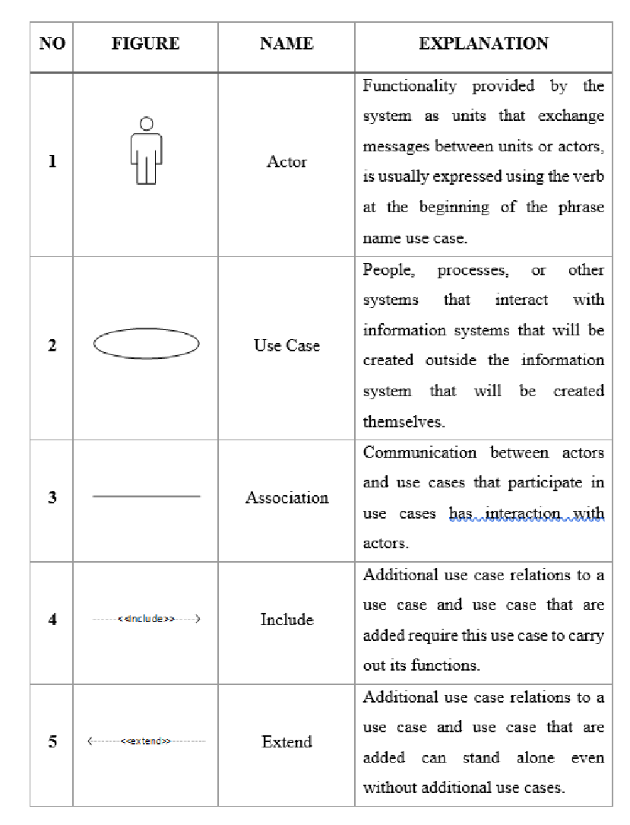
Figure 1. Notiations

2.2.2 System Overview
Flights Tickets Booking
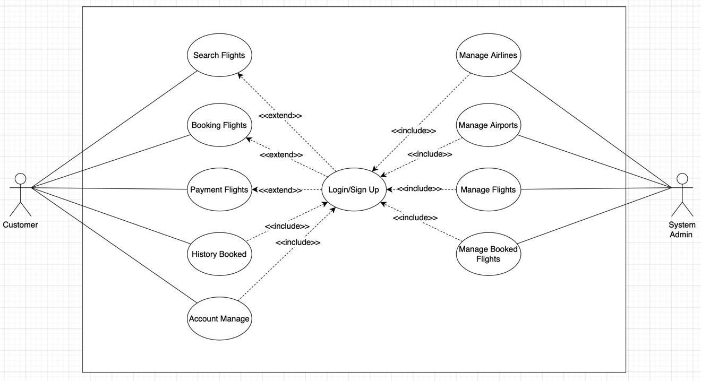
Figure 2. Use case diagram – System overview

2.2.3 Usecase Search Flights
- Usecase detail
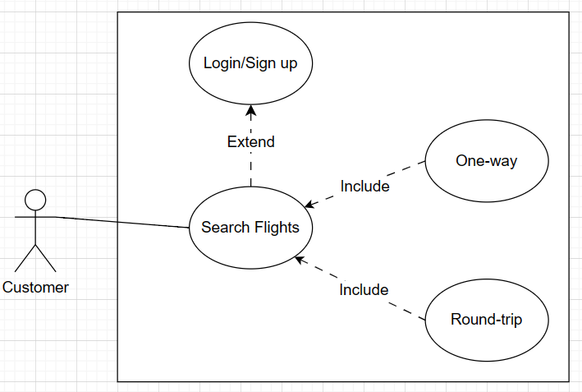
Figure 3. Use case diagram – Search Flights

- Use Case Description
*Usecase Search Flights*
Use case Name: | UC1: Search Flights
Scope: | Focuses on the user to access flight information search features.
Level: | It is very important because searching is necessary so that customers can clearly understand the information they need to search for and choose to booking flight.
Primary actor: | Customer
Stakeholders & Interests: | Customer: Interested in searching for available flights.
Pre-conditions: | - May or may not be able to log in to the system.  - Search for reasonable flight information proposed from the system.  - Search flights must be available, otherwise changing flight information is more reasonable.
Success Guarantee: | - Actor successfully finds a flight and will be directed to the flight booking board.
Main Success Scenario: | - If Actor don’t want to login:  1.1. Actor enters flight information to search.  - If Actor want to login first:  1.2. Actor login/sigup then return to homepage to input flight information to search.  2. Actor press “Search”.  3. The system displays available flights.
Extensions: | - If Actor fill lack of information:  1.1. and 1.2. The system displays “Please fill all the fields”.  Return to Main flow #1.1. or #1.2.
Technology and Data Variations List: | Actor's data will be securely stored in the database.
Frequency of Occurrence: | This use case occurs whenever an actor wants to access the application.
Special Requirements: | - The system must ensure fast response times when users use the search feature.  - The search interface must be user-friendly, providing a smooth user experience.

2.2.4 Usecase Booking Flights
- Usecase detail
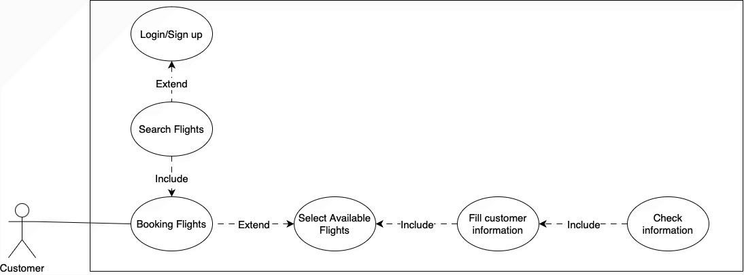
Figure 4. Use case diagram – Booking Flights

B. Use Case Description
*Usecase Booking Flights*
Use case Name: | UC2: Booking Flights
Scope: | Focus on the userr booking flights.
Level: | This is very important because booking air tickets is necessary for customers to have a flight with full information and a fully confirmed flight ticket.
Primary actor: | Customer.
Stakeholders & Interests: | Customer: Interested in booking a flight.
Pre-conditions: | - May or may not be able to log in to the system.  - Actor has searched for flights.
Success Guarantee: | - Actor successfully books a flight and will be directed to the payment board.
Main Success Scenario: | - If Actor don’t want login:  1.1. Actor choose a suitbale and available flight and press “Book now”.  2.1. Actor fills all information display on the screen: Contact information and Passenger Information.  - If Actor want login:  1.2. Actor choose a suitbale and available flight and press “Book now”.  2.2. Actor fills all information display on the screen: Passenger Information.  3. Actor press “Submit”.
Extensions: | - Fill lack of information:  2.1. and 2.2. The system displays “Please fill all the information”.
Technology and Data Variations List: | Data about flights and booking flights will be stored securely in the database.
Frequency of Occurrence: | This use case occurs whenever an actor wants to access the application.
Special Requirements: | - The system must ensure fast response times when users use the booking feature.  - The booking interface must be user-friendly, providing a smooth user experience.

2.2.5 Usecase Payment Flights
A. Usecase detail
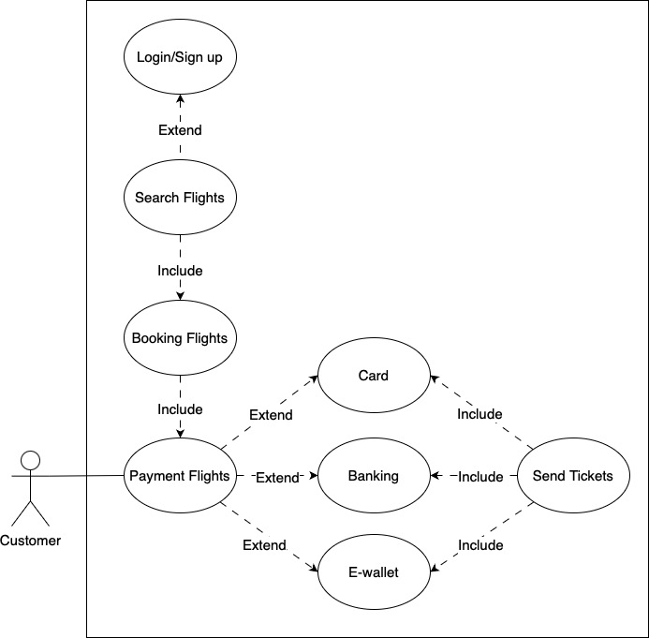
Figure 5. Use case diagram – Payment Flights

B. Use Case Description
* Use cases Payment Flights*
Use case Name: | UC3: Payment Flights
Scope: | Focuses on payment flight to get tickets.
Level: | High importance level related to the activity of getting flight tickets.
Primary actor: | Customer.
Stakeholders & Interests: | Customer: Concerned with payment flights to get ticket.
Pre-conditions: | - May or may not be able to log in to the system.  - Actor has finished booking, fill out information process and confirm all the informations.
Success Guarantee: | Actor successfully get tickets.
Main Success Scenario: | - If Actor don’t want to login:  1. Actor chooses one of three methods for payment (Card or Banking or E-wallet).  - If Actor choose “Card”:  2.1. Actor fill all Card’s infomation: Card number, Expired date and CVC.  3.1. Actor press “Pay now”.  4.1. The system sends OTP code to customer’s phone number or email.  5.1. The system notifice “Payment succesfully!”.  - If Actor choose “Banking”:  2.2. Actor fill all Banking’s infomation: Card number, Expired date and CVC.  3.2. Actor press “Pay now”.  4.2. The system sends OTP code to customer’s phone number or email.  5.2. The system notifice “Payment succesfully!”.  - If Actor chooses “E-wallet”:  2.3. The system display time remain for payment to access and their information include QR-code to scan.  3.3. Actor checks the information and press “Confirm”.  4.3. Actor press load page. The system notifice “Payment succesfully!”.  - If Actor want to login:  - If Actor choose “Card”:  2.1.1. Actor check all Card’s infomation and press “Pay now”.  3.1.1. The system sends OTP code to customer’s phone number.  4.1.1. The system notifice “Payment succesfully!”.  - If Actor choose “Banking”:  2.2.1. Actor check all Banking’s infomation and press “Pay now”.  3.2.1. The system sends OTP code to customer’s phone number.  4.2.1. The system notifice “Payment succesfully!”.  - If Actor chooses “E-wallet”:  2.3.1. The system display time remain for payment to access and their information include QR-code to scan.  3.3.1. Actor checks the information and press “Confirm”.  4.3.1. Actor press load page. The system notifice “Payment succesfully!”.
Extensions: | - Actor fills lack of information:  2.1. and 2.2. The system display “Please enter complete information in all fields!”.  4.1. and 4.2. and 3.1.1. and 3.2.1. The system display “Please press Resend to fill again”.  - Actor fills incorrect information:  2.1. and 2.2. The system display “Card banking don’t exist. Please fill again the information”.  4.1. and 4.2. and 3.1.1. and 3.2.1. The system display “Please press Resend to fill again”.  - Actor log in and first time payment by card and banking:  2.1.1.1. and 2.2.1.1. Actor fill all information of banking card
Special Requirements | The system must ensure fast response times when users use the payments feature.  The payment interface must be user-friendly, providing a smooth user experience.  The system needs three support secure and convenient online payment methods.
Frequency of Occurrence: | This usecase occurs frequently.
Technology and Data Variations List: | The system stores new ticket and flights into booked flight.

2.2.6 Usecase History Booked
A. Usecase detail
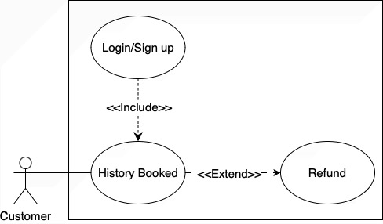
Figure 6. Use case diagram – History Booked

B. Use Case Description
*Usecase Refund*
Use case Name: | UC4: Refund Tickets
Scope: | Focus on the list of booked air tickets so you can use the refund feature.
Level: | This is very important because airline ticket bookings sometimes cause errors and mistaken information from customers, sudden changes in flights, and user requests.
Primary actor: | Customer.
Stakeholders & Interests: | Customer: Interested in get back their money and canceling tickets.
Pre-conditions: | - Must be able to log in to the system.  - Click on the dashboard “History Flights” section.
Success Guarantee: | - The system sends request to Admin to accept When the user requiments refund the flight ticket.
Main Success Scenario: | 1. Actor selects a ticket to cancel and get refund. Actor choose “Request Refund”.  2. The system displays “Confirm Refund” page. Actor choose “Refund”  3. The system displays “Please wait for response from admin”  4. Actor press “Close”.
Extensions: | 2.1. Actor choose “Cancel”:  Return to “Refund” page.
Technology and Data Variations List: | The system needs have interface with highlights color for customer to recognize their status including: red stand for used and canceling tickets, yellow stand for waiting for response, green stand for available tickets and grey stand for unsuccessfully refund tickets.
Frequency of Occurrence: | Not periodic.
Special Requirements: | The system need to supose various refund methods.  Refund policies and criteria for validity need to clearly defined and accessible.

2.2.7 Usecase Manage Account
A. Usecase detail
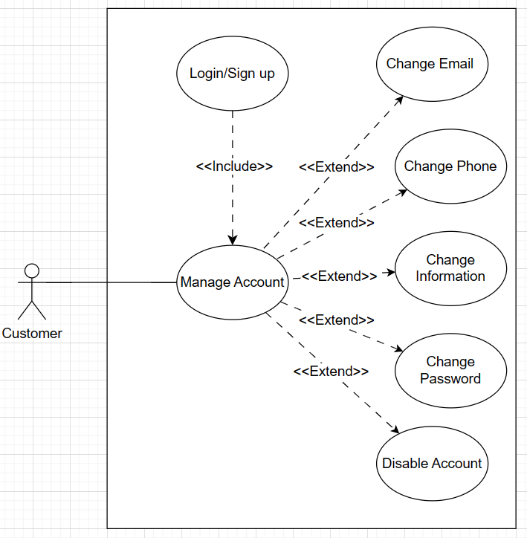
Figure 7. Use case diagram – Manage Account

B. Use Case Description
* Usecase Change Email*
Use case Name: | UC5: Change Email
Scope: | Focuses on changing emails.
Level: | Depend on user’s demand.
Primary actor: | Customer.
Stakeholders & Interests: | Customer: Concerned with changing email.
Pre-conditions: | - Actor must have an account.  - Actor must be logged into the system.
Success Guarantee: | Actor successfully change their Email.
Main Success Scenario: | 1. Actor selects the "Account" section. The system display “Account” page.  2. Actor choose the “Change Email” section.  3. The system display “New Email” page. Actor fills new email.  4. The system send mail to new email to confirm.  5. Actor return the system and the system display “Change email successfully!”.
Extensions: | 3.1. If email input lack of information:  3.1.1. The system display “Your email incorrect”.  3.2. If email don’t exist:  3.2.1. The system display “Your email doesn’t exist”.
Special Requirements | Actor's new data will be updated and securely stored in the database.
Frequency of Occurrence: | This use case occurs whenever an actor wants to change their email.
Technology and Data Variations List: | All actor personal information needs to be protected and encrypted to ensure security.

* Usecase Change Phone Number*
Use case Name: | UC6: Change Phone Number
Scope: | Focuses on changing phone number.
Level: | Depend on user’s demand.
Primary actor: | Customer.
Stakeholders & Interests: | Customer: Concerned with changing phone number.
Pre-conditions: | Actor must have an account.  Actor must be logged into the system.
Success Guarantee: | Actor successfully change their phone number.
Main Success Scenario: | 1. Actor selects the "Account" section. The system display “Account” page.  2. Actor choose the “Change Phone Number” section.  3. The system display “New Phone Number” page. Actor fills new phone number.  4. The system send code to new phone number to confirm.  5. Actor return the system and the system display “Change phone number successfully!”.
Extensions: | 3.1. If phone number input lack of numbers:  3.1.1. The system display “Your phone number unidentify”.  3.2. If phone number don’t exist:  3.2.1. The system display “Your phone number doesn’t exist”.
Special Requirements | Actor's new data will be updated and securely stored in the database.
Frequency of Occurrence: | This use case occurs whenever an actor wants to change their phone number.
Technology and Data Variations List: | All actor personal information needs to be protected and encrypted to ensure security.

* Usecase Change Information*
Use case Name: | UC7: Change Information
Scope: | Focuses on changing Information.
Level: | Depend on user’s demand.
Primary actor: | Customer.
Stakeholders & Interests: | Customer: Concerned with changing information.
Pre-conditions: | Actor must have an account.  Actor must be logged into the system.
Success Guarantee: | Actor successfully change their information.
Main Success Scenario: | 1. Actor selects the "Account" section. The system display “Account” page.  2. Actor choose the “Change Informations” section.  3. The system display “New Informations” page. Actor fills new informations.  4. Actor press “Save”.  5. The system and the system display “Change informations successfully!”.
Extensions: | None.
Special Requirements | Actor's new data will be updated and securely stored in the database.
Frequency of Occurrence: | This use case occurs whenever an actor wants to change their information.
Technology and Data Variations List: | All actor personal information needs to be protected and encrypted to ensure security.

* Usecase Change Passwords *
Use case Name: | UC8: Change Passwords
Scope: | Focuses on changing passwords.
Level: | Depend on user’s demand.
Primary actor: | Customer.
Stakeholders & Interests: | Customer: Concerned with changing passwords.
Pre-conditions: | Actor must have an account.  Actor must be logged into the system.
Success Guarantee: | Actor successfully change their passwords.
Main Success Scenario: | 1. Actor selects the "Account" section. The system display “Account” page.  2. Actor choose the “Change Password” section.  3. The system display “New Password” page. Actor fills all fields: Old password, New password and Confirm New password.  4. Actor press “Save”.  5. The system display “Change password successfully!”.
Extensions: | 3.1. If Old password input incorrect:  3.1.1. The system display “Your old password wrong”.  3.2. If New password and Confirm New password don’t match:  3.2.1. The system display “Your new password don’t match”.
Special Requirements | Actor's new data will be updated and securely stored in the database.
Frequency of Occurrence: | This use case occurs whenever an actor wants to change their password.
Technology and Data Variations List: | All actor personal information needs to be protected and encrypted to ensure security.

* Usecase Disable Account*
Use case Name: | UC9: Disable Account
Scope: | Focuses on disable account.
Level: | Depend on user’s demand.
Primary actor: | Customer.
Stakeholders & Interests: | Customer: Concerned with disable their account.
Pre-conditions: | Actor must have an account.  Actor must be logged into the system.
Success Guarantee: | Actor successfully disable account.
Main Success Scenario: | 1. Actor selects the "Account" section. The system display “Account” page.  2. Actor choose the “Disable Account” section.  3. The system display “Confirm Disable Account” page. Actor press “confirm”  4. Return actor don’t have account homepage.
Extensions: | 3.1. Actor press “Cancel”:  Return actor “account” page.
Special Requirements | Actor's account will be disable in the database.
Frequency of Occurrence: | This use case occurs whenever an actor wants to disable account.
Technology and Data Variations List: | None.

2.2.8 Usecase Login/Sign Up
A. Usecase detail
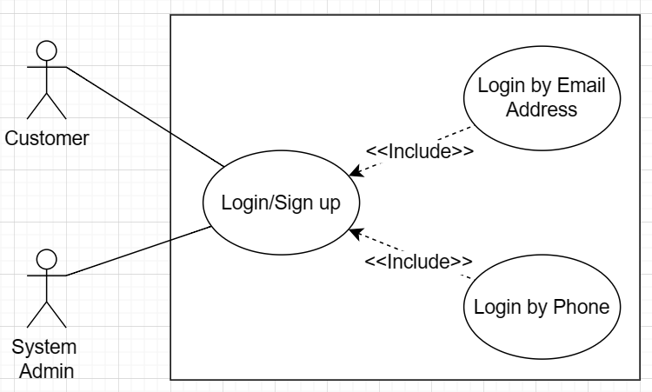
Figure 8. Use case diagram – Login/Sign Up

B. Use Case Description
* Usecase Login/Sign Up*
Use case Name: | UC10: Login/Sign Up
Scope: | Focuses on actors logging in or sign up into the system to access features.
Level: | Very important as logging in or sign up is necessary for actors to observe and perform other tasks.
Primary actor: | Customer, System Admin
Stakeholders & Interests: | Customer: Interested in sign up an account or log in when already have an account.  System Admin: Interested in log in an account.
Pre-conditions: | - If Customer choose login, their must have been previously sign up.  - Valid account with login information.  - Actor access to the system.
Success Guarantee: | - Actor logs in and sign up successfully and is directed to the actor’s role homepage.
Main Success Scenario: | - If Customer want to sign up:  1. Actor selects “SignUp/Login” section on their’s homepage.  2. The system display “SignUp/Login” page.  3. Actor choose SignUp options: By Email, By Phone number.  3.1. If Customer choose Sign up by Email:  3.1.1. The system display Email input to fill then send a mail through the email their just provide to confirm.  3.1.2. Return to their Sign Up page. The system display other personal information for Customer to fill.  3.1.3. Actor press “Save”. The system display “Log in successfully!”  3.2. If Customer choose Sign up by Phone number:  3.2.1. The system display Phone number input to fill then send a mail through the phone number their just provide to confirm.  3.2.2. Return to their Sign Up page. The system display other personal information for Customer to fill.  3.2.3. Actor press “Save”. The system display “Log in successfully!”  - If Customer want to log in:  4. Actor choose Log In options: By Email, By Phone number.  4.1. If Customer choose Log In by Email:  4.1.1. The system display Email input to log in.  4.1.2. Customer press “Log in”.  4.1.3. Customer enters their password.  4.1.4. The system display “Log in successfully!”  4.2. If Customer choose Log In by Phone number:  4.2.1. The system display Phone number input to log in.  4.2.2. Customer press “Log in”.  4.2.3. Customer enters their password.  4.2.4. The system display “Log in successfully!”  - If Actor is Admin:  5. Admin enters their account’s name.  6. The system display password for Admin to fill. Admin fill password.  7. Admin press “Log in”.  9. The system display “Log in successfully!”
Extensions: | - If Customer fill Email or Phone number or Password for sign up incorrect:  3.1.3. and 3.2.3. and 4.1.3. and 4.2.3. The system notifies “Email or Phone number unidentify”.  Return to #2 in Main flow.  - If Customer Log in account don’t exist:  4.1.2. and 4.2.2. The system notifies “Email or Phone number hasn’t been sign up. Do you want to continue to register?”.  4.1.2.1. and 4.2.2.1. Actor press “Continue”:  Return to #2 in Main flow.
Technology and Data Variations List: | Actor's login or sign up data will be securely stored in the database.
Frequency of Occurrence: | This use case occurs whenever an actor wants to access the application.
Special Requirements: | All actor login or sign up information needs to be protected and encrypted to ensure security.

2.2.9 Manage Airlines
A. Usecase detail
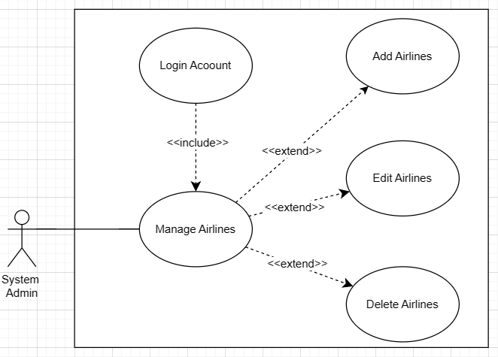
Figure 9. Use case diagram – Manage Airlines

B. Use Case Description
* Usecase Add Airlines*
Use case Name: | UC11: Add Airlines
Scope: | Focuses on adding a flight.
Level: | High importance level directly related to the main activity of creating new flights.
Primary actor: | System Admin
Stakeholders & Interests: | System Admin: Concerned with adding flights.
Pre-conditions: | Actor must have an account.  Actor must be logged into the system.
Success Guarantee: | Actor successfully adds a flight.
Main Success Scenario: | 1. Actor selects “Manage Airline” section and choose "Add Airline" section.  2. Actor fill the information and press “Submit”.  3. System notifies “Airline added successfully”. Actor press “Close”.
Extensions: | 2.1. If Actor does not fill in complete information:  2.1.1. The system notifies “Input lack of information. Please fill all fields”.  2.2. If actor fill an airline with the same email already exist:  2.2.1. The system notifies “Airline with this email already registed”.  2.3. If actor fill an airline with the same name already exist:  2.3.1. The system notifies “The airline name is already taken”.
Special Requirements | None
Frequency of Occurrence: | Not periodic.
Technology and Data Variations List: | The system stores information about new airline into databases.

* Use cases Edit Airlines *
Use case Name: | UC12: Edit Airlines
Scope: | Focuses on editing an airline information.
Level: | Medium importance level directly related to the main activity of showing airlines information.
Primary actor: | System Admin.
Stakeholders & Interests: | System Admin: Concerned with updating airlines information.
Pre-conditions: | Actor must have an account.  Actor must be logged into the system.
Success Guarantee: | Actor successfully update new information for airlines.
Main Success Scenario: | 1. Actor selects the "Airlines" section.  2. The system displays a list of airlines that under the managementt.  3. Actor choose an airline to edit and press “Edit”.  4. The system displays “Edit Airline” page.  5. Actor fill new information.  6. Actor press “Save Changes”.  7. System notifies “Record updated successfully”. Actor press “Close”.
Extensions: | 6.1. Actor press “Cancel”:  Return to “Airlines” page with unupdated information.
Special Requirements | None.
Frequency of Occurrence: | Not periodic.
Technology and Data Variations List: | The system stores updated information into database.

* Usecase Delete Airlines*
Use case Name: | UC13: Delete Airlines
Scope: | Focuses on deleting an airline.
Level: | Low importance level related to the activity of showing airlines information.
Primary actor: | System Admin.
Stakeholders & Interests: | System Admin: Concerned with deleting inactive airline.
Pre-conditions: | Actor must have an account.  Actor must be logged into the system.
Success Guarantee: | Actor successfully deletes an airline.
Main Success Scenario: | 1. Actor selects the "Airlines" section.  2. The system displays a list of airlines that under the management.  3. Actor choose an airline to delete and press “Delete”.  4. The system displays “Cofirm Delete” page.  5. Actor press “Delete”.  6. System notifies “Airline deleted successfully”. Actor press “Close”.
Extensions: | 5.1. Actor press “Cancel”:  Return to “Airlines” page with undeleted airline.
Special Requirements | None
Frequency of Occurrence: | Not periodic.
Technology and Data Variations List: | The system stores new list of airlines.

2.2.10 Usecase Manage Airports
A. Usecase detail
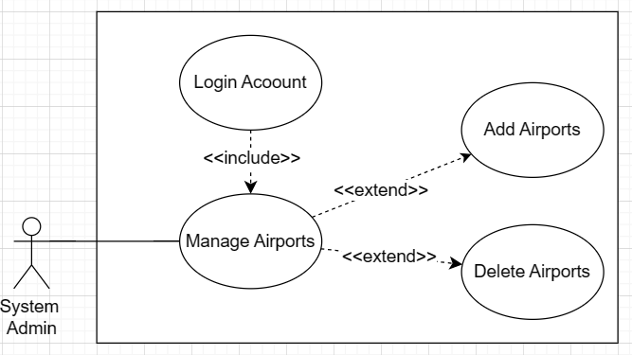
Figure 10. Use case diagram – Manage Airports

B. Use Case Description
* Usecase Add Airports*
Use case Name: | UC14: Add Airports
Scope: | Focuses on adding airports.
Level: | High importance level directly related to the main activity of creating new airports.
Primary actor: | System Admin
Stakeholders & Interests: | System Admin: Concerned with adding airports.
Pre-conditions: | Actor must have an account.  Actor must be logged into the system.
Success Guarantee: | Actor successfully adds an airports.
Main Success Scenario: | 1. Actor selects the "Airports" section.  2. The system displays a list of airport that under the managementt.  3. Actor fill the information and press “Submit”.  4. System notifies “Successfully inserted”. Actor press “Close”.
Extensions: | 4.1. If Actor does not fill in complete information:  4.1.1. The system notifies “Please fill all information”.
Special Requirements | None
Frequency of Occurrence: | Not periodic.
Technology and Data Variations List: | The system stores new airports into databases.

* Use case Delete Airports *
Use case Name: | UC15: Delete Airports
Scope: | Focuses on deleting an airport.
Level: | Low importance level related to the activity of showing airport information.
Primary actor: | System Admin.
Stakeholders & Interests: | System Admin: Concerned with deleting inactive airport.
Pre-conditions: | Actor must have an account.  Actor must be logged into the system.
Success Guarantee: | Actor successfully deletes an airport.
Main Success Scenario: | 1. Actor selects the "Airports" section.  2. The system displays a list of airports that under the managementt.  3. Actor choose an airport to delete and press “Delete”.  4. The system displays “Cofirm Delete” page.  5. Actor press “Delete”.  6. System notifies “Airport deleted successfully”. Actor press “Close”.
Extensions: | 5.1. Actor press “Cancel”:  Return to “Airports” page with undeleted airport.
Special Requirements | None
Frequency of Occurrence: | Not periodic.
Technology and Data Variations List: | The system stores new list of airports.

2.2.11 Usecase Manage Flights
A. Usecase detail
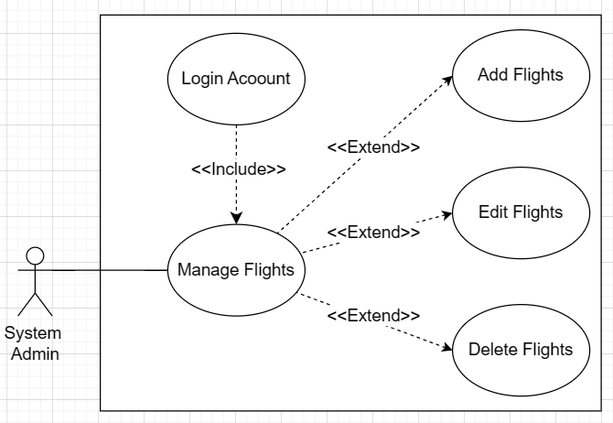
Figure 11. Use case diagram – Manage Flights

B. Use Case Description
* Usecase Add Flights *
Use case Name: | UC16: Add Flights
Scope: | Focuses on adding a flight.
Level: | High importance level directly related to the main activity of creating new flights.
Primary actor: | System Admin
Stakeholders & Interests: | System Admin: Concerned with adding flights.
Pre-conditions: | Actor must have an account.  Actor must be logged into the system.
Success Guarantee: | Actor successfully adds a flight.
Main Success Scenario: | 1. Actor selects the "Manage Flights" section and choose “Add Flight”.  2. The system displays “ADD FLIGHT DETAILS” page.  3. Actor fill the information and press “Submit”.  4. System notifies “Successfully inserted”. Actor press “Close”.
Extensions: | 3.1. If Actor does not fill in complete information:  3.1.1. The system notifies “Fill out all information”.  3.2. If Actor fill Destination date or time is less than source date or time:  3.2.1. The system notifies “Dest. date/time is less than src”  3.3. If actor fill same airport in source and destination:  3.3.1. The system notifies “Same city specified in source and destination”
Special Requirements | None
Frequency of Occurrence: | Not periodic.
Technology and Data Variations List: | The system stores new information about flights.

* Use cases Edit Flights*
Use case Name: | UC17: Edit Flights
Scope: | Focuses on editing a flight information.
Level: | Medium importance level directly related to the main activity of showing flights information.
Primary actor: | System Admin.
Stakeholders & Interests: | System Admin: Concerned with updating flights information.
Pre-conditions: | Actor must have an account.  Actor must be logged into the system.
Success Guarantee: | Actor successfully update new information for flights.
Main Success Scenario: | 1. Actor selects the "Manage Flights" section.  2. The system displays a list of flights that under the managementt.  3. Actor choose an airline to edit and press “Edit”.  4. The system displays “Edit Flight” page.  5. Actor fill new information.  6. Actor press “Save Changes”.  7. System notifies “Record updated successfully”. Actor press “Close”.
Extensions: | 6.1 Actor press “Cancel”:  Return to “Manage Flights” page with unupdated information.
Special Requirements | None.
Frequency of Occurrence: | Not periodic.
Technology and Data Variations List: | The system stores updated flights information into database.

* Use case Delete Flights*
Use case Name: | UC18: Delete Flights
Scope: | Focuses on deleting a flight.
Level: | Low importance level related to the activity of showing flights information.
Primary actor: | System Admin.
Stakeholders & Interests: | System Admin: Concerned with deleting inactive flights.
Pre-conditions: | Actor must have an account.  Actor must be logged into the system.
Success Guarantee: | Actor successfully deletes an flights.
Main Success Scenario: | 1. Actor selects the "Manage Flights" section.  2. The system displays a list of flightsthat under the managementt.  3. Actor choose an airline to delete and press “Delete”.  4. The system displays “Cofirm Delete” page.  5. Actor press “Delete”.  6. System notifies “Flight deleted successfully”. Actor press “Close”.
Extensions: | 5.1. Actor press “Cancel”:  Return to “Manage Flights” page with undeleted flights.
Special Requirements | None
Frequency of Occurrence: | Not periodic.
Technology and Data Variations List: | The system stores new list of flights.

2.2.12 Usecase Manage Booked Flight
A. Usecase detail
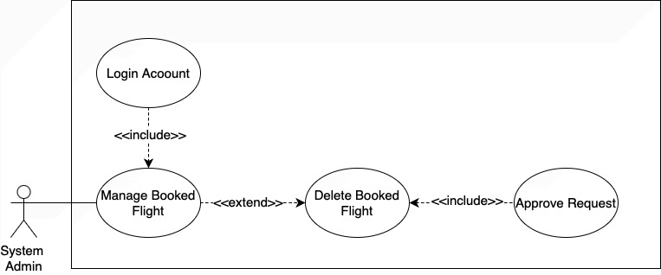
Figure 12. Use case diagram – Manage Booked Flight

B. Use Case Description
* Usecase Delete Booked Flight*
Use case Name: | UC19: Delete Booked Flights
Scope: | Focuses on canceling a booked flight.
Level: | Low importance level related to the activity of showing booked flight cancel request.
Primary actor: | System Admin.
Stakeholders & Interests: | System Admin: Concerned with approve request for canceling booked flights and refund to customer.
Pre-conditions: | Actor must have an account.  Actor must be logged into the system.
Success Guarantee: | Actor successfully approving cancel request.
Main Success Scenario: | 1. Actor selects the "Manage Booked Flights" section.  2. The system displays a list of booked flights that under the management and choose the flight that show special effect for Actor to approve request for canceling flight.  3. Actor choose ”Delete”.  4. The system displays two optionals: “Confirm” or “Refuse” on notified.  5. Actor press “Confirm”.  6. The system display a notification “Booking deleted successfully”. Actor press “Close” and ticket disappear.
Extensions: | 5.1. If actor press “Refuse”:  5.1.1. The system display a notification “Refuse Successfully” and ticket stay there.
Special Requirements | - The system needs to make a notified sound when there are requests for refund and display highlights color: green stand for available booked flights and unapproved refund tickets, yellow stand for waiting for response admin.
Frequency of Occurrence: | Not periodic.
Technology and Data Variations List: | The system stores new list of booked flights.

2.3 Domain Model
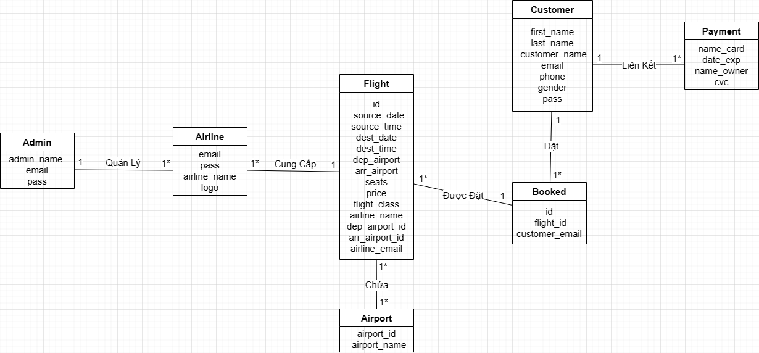

2.4 Class Diagram
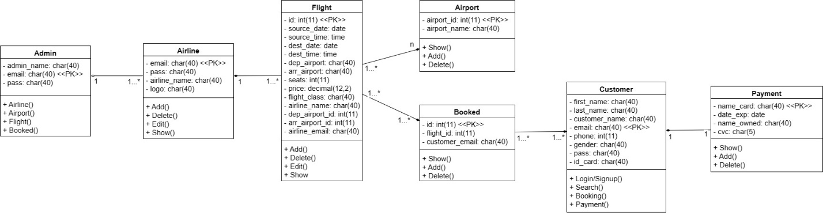

3. Quality Attribute
ID | Quality | Attribute | Description
QAR001 | Performance | Response Time | The website should have fast response times, ensuring that users can search for flights, view options, and complete bookings swiftly to enhance user experience and satisfaction.
QAR002 | Reliability | Availability | The website should be available 24/7 with minimal downtime to ensure that users can access flight information and make bookings at any time without disruptions.
QAR003 | Security | Data Protection | The website should employ robust security measures to protect users' personal and financial information, including secure encryption protocols for transactions and compliance with relevant data protection regulations.
QAR004 | Usability | Intuitiveness | The website should have a user-friendly interface with intuitive navigation, clear layout, and easy-to-use booking process, catering to users of varying technical proficiency and ensuring a smooth booking experience.
QAR005 | Scalability | Concurrent Users Handling | The website should be able to handle a large number of concurrent users during peak times without performance degradation or system crashes, ensuring consistent availability and responsiveness.
QAR006 | Compatibility | Cross-Browser Support | The website should be compatible with major web browsers (e.g., Chrome, Firefox, Safari) and devices (e.g., desktops, tablets, smartphones), ensuring a consistent experience across different platforms.
QAR007 | Performance | Load Time | The website should have optimized load times for pages and content, minimizing waiting times for users and improving overall user satisfaction and engagement.
QAR008 | Flexibility | Customization Options | The website should offer customization options for users, such as filters for search results and personalized notifications, enhancing user control and satisfaction.
QAR009 | Reliability | Transaction Integrity | The website should ensure transaction integrity, including accurate booking information and reliable payment processing, to instill trust and confidence in users.
QAR010 | Performance | Search Efficiency | The website's search functionality should be fast and efficient, allowing users to quickly find relevant flight options based on their preferences, dates, and destinations, enhancing user satisfaction and conversion rates.
QAR011 | Accuracy | Flight Information Reliability | The website should ensure the accuracy and reliability of flight information, including schedules, availability, and pricing, by integrating with reliable data sources and updating information in real-time, avoiding confusion and disappointment for users.

4. Constraints

4.1 Business Constraints
- 3 people.
- 6 weeks.

4.2 Technical Constraint list
Consideration | Technical Constraints
Computer Operating System | Windows,Ios
Computer platform | Intel based processor
Computer languages | None
Peripheral or network hardware | None
Commercial hardware or software products | None
Tools and method | None
Protocols, interfaces, standards | .NET 4.0
Legacy hardware and software | None

5. Graphical User Interface Description

5.1 SignUp/LogIn Screen:
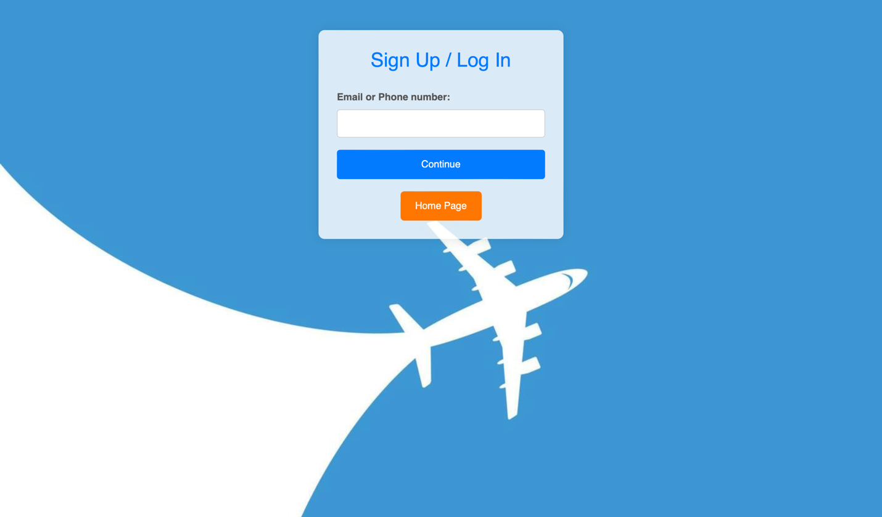
- SignUp/LogIn page.
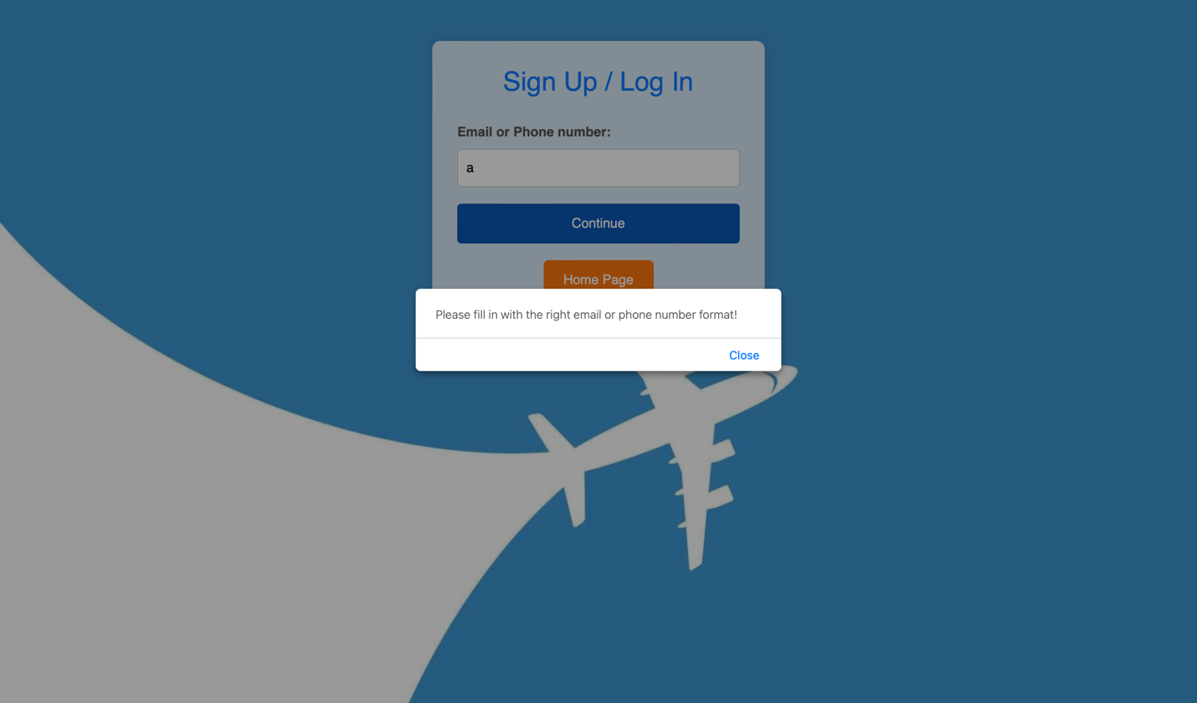
- Input error wrong format for email or phone number.
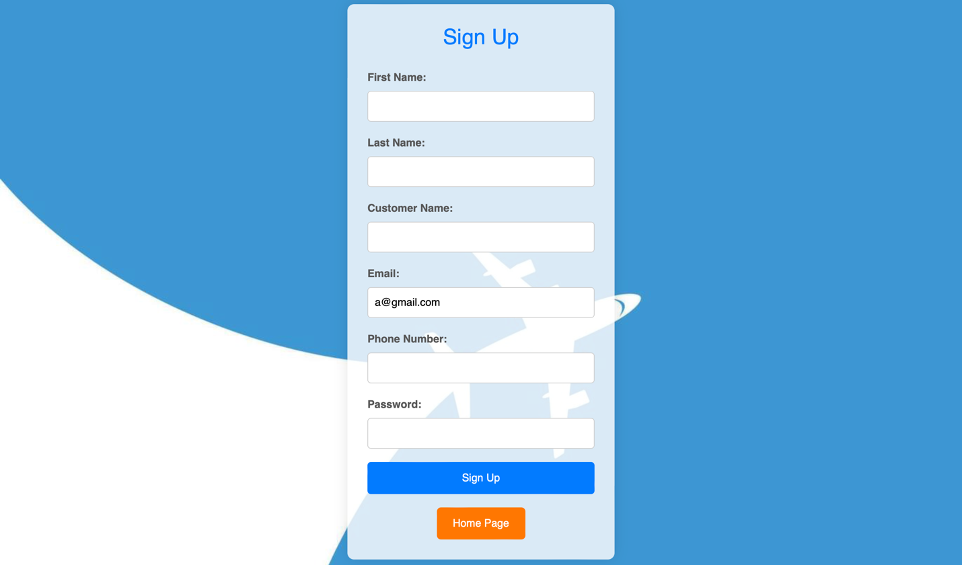
- Sign Up page.
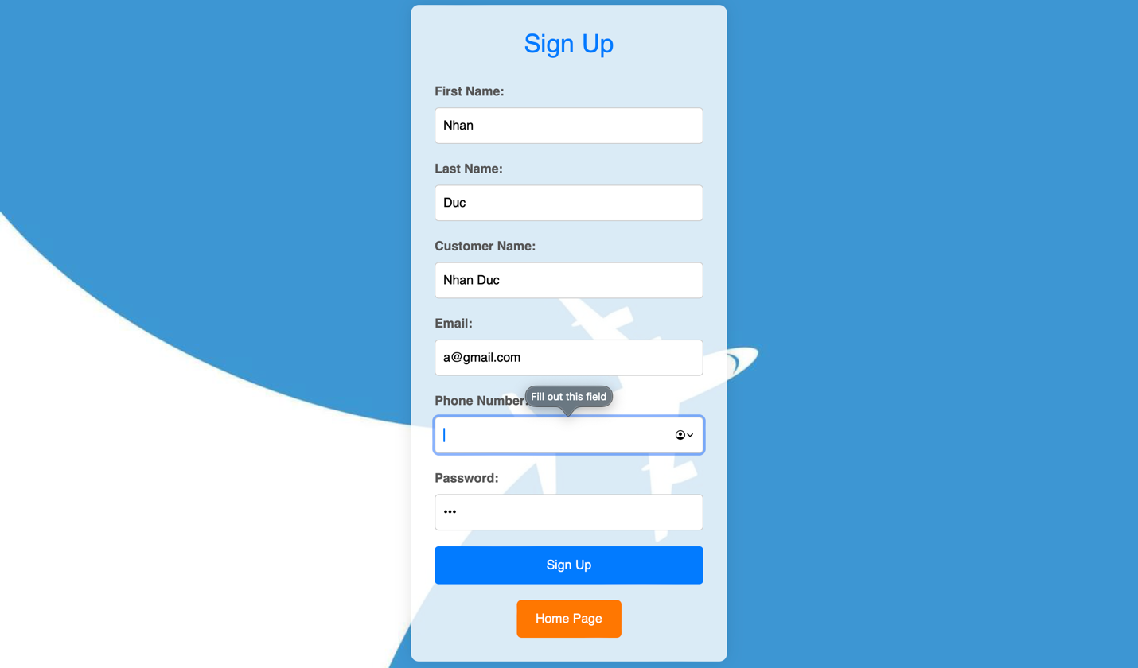
- Error lack of information.
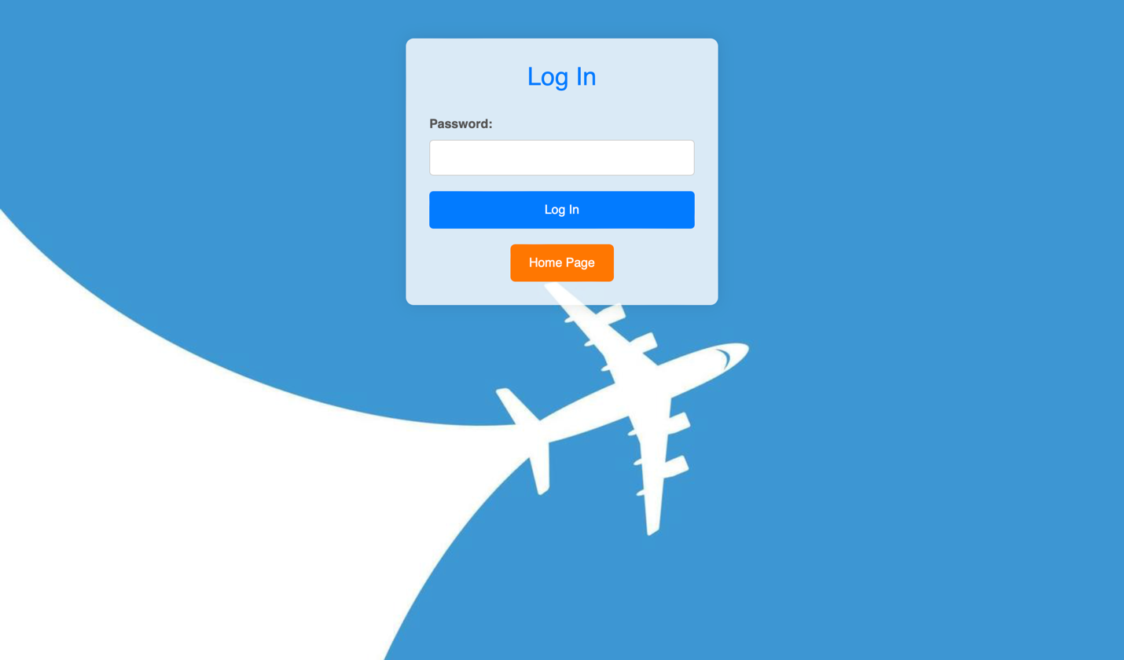
- Log In page.
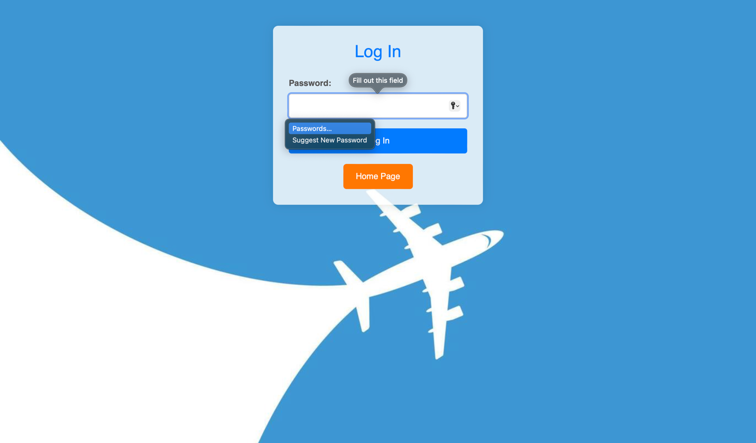
- Input lack of information.
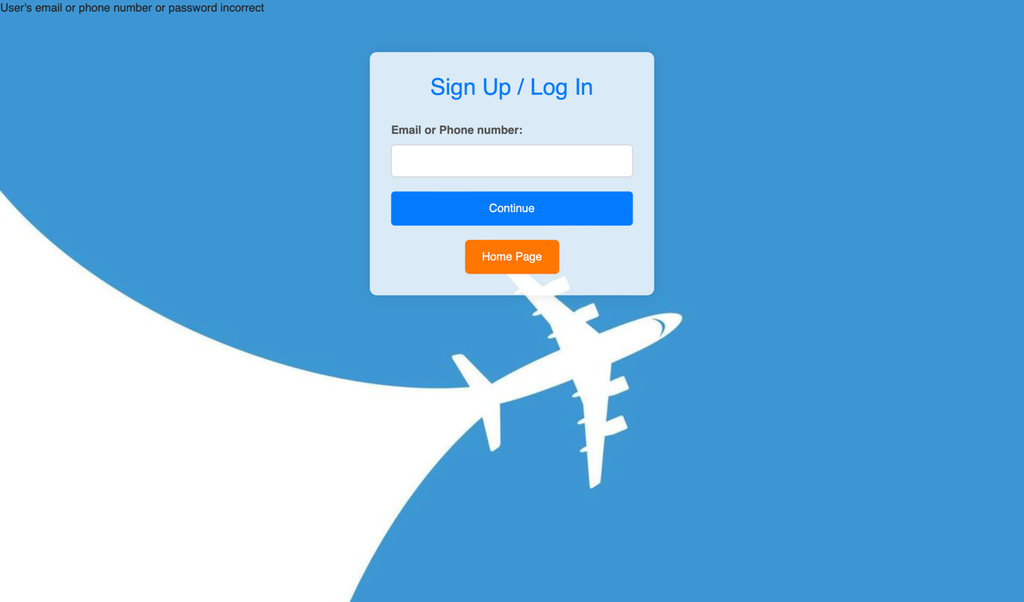
- Email or phone number or password incorrect.

5.2 Search Screen:
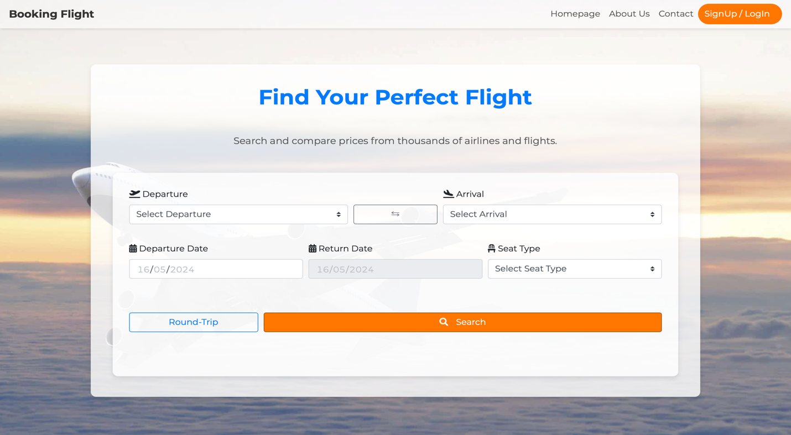
- Search page (One-Way)
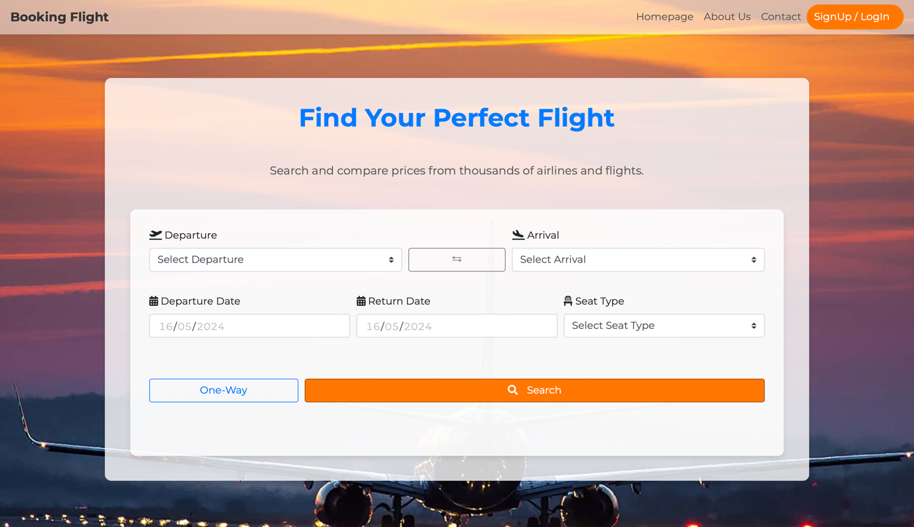
- Search page (Round-Trip).
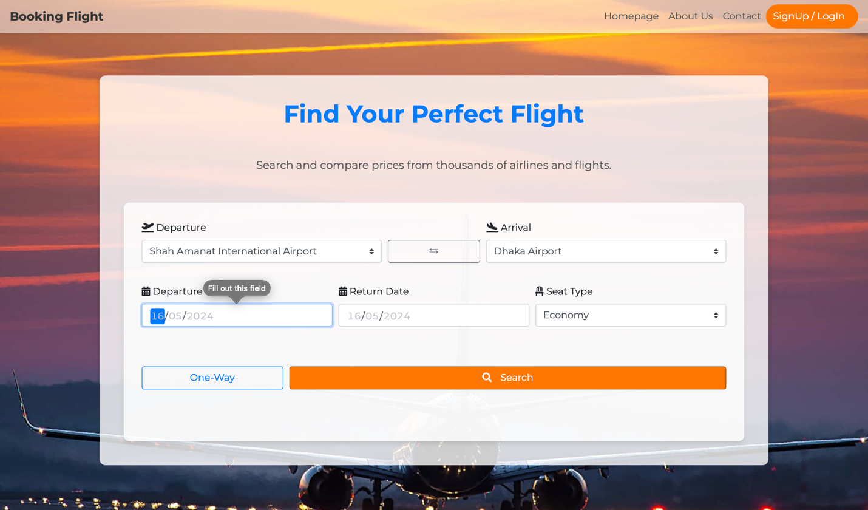
- Error lack of information.
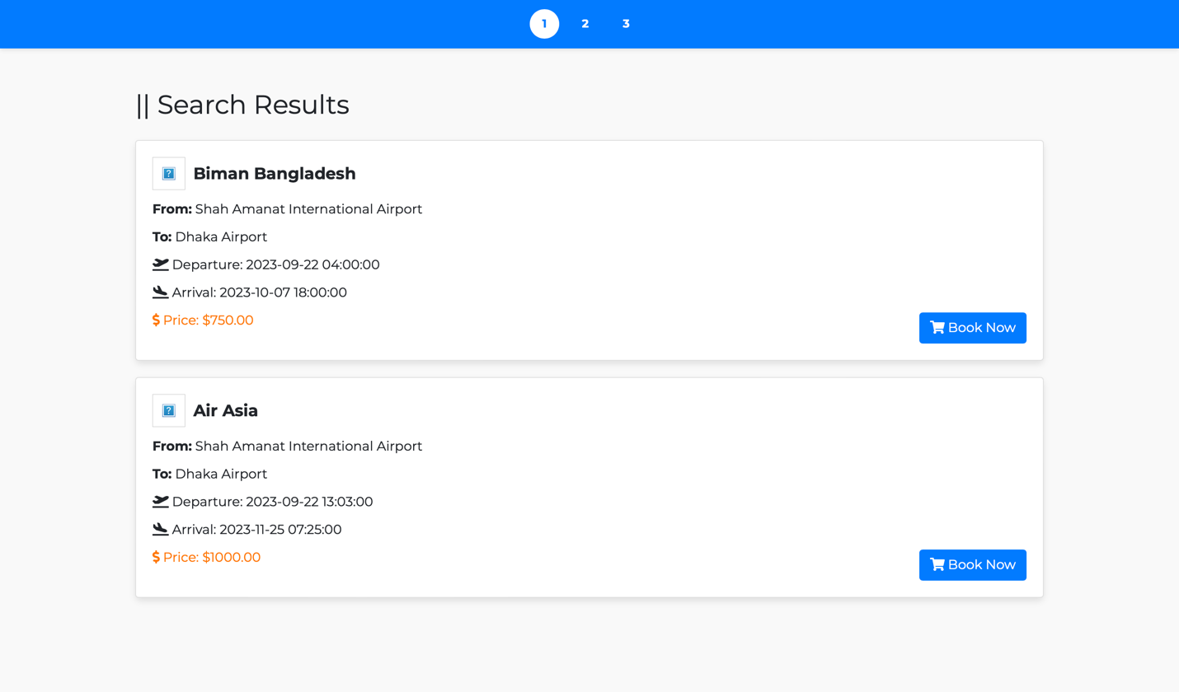
- Search results.
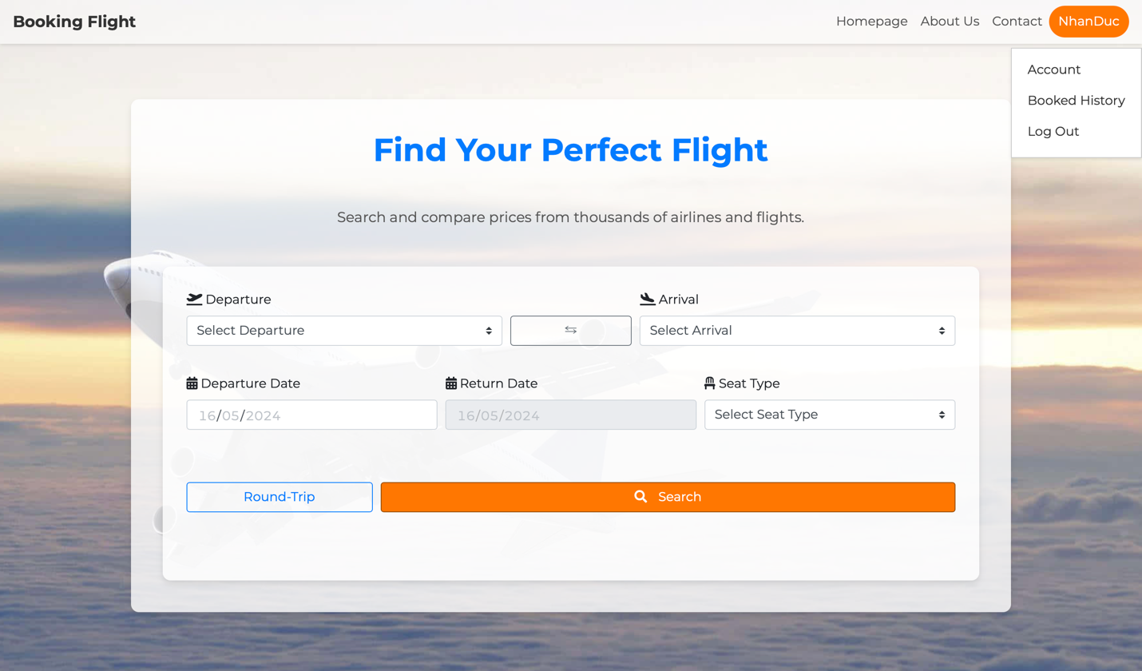
- Search page when user log in.

5.3 Booking Screen:
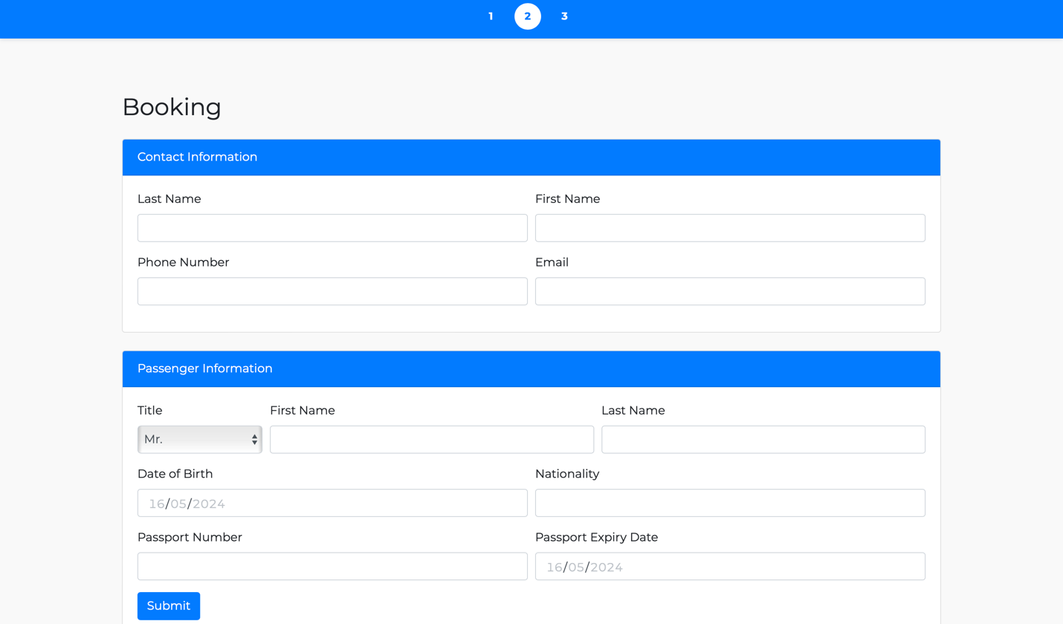
- Booking page.
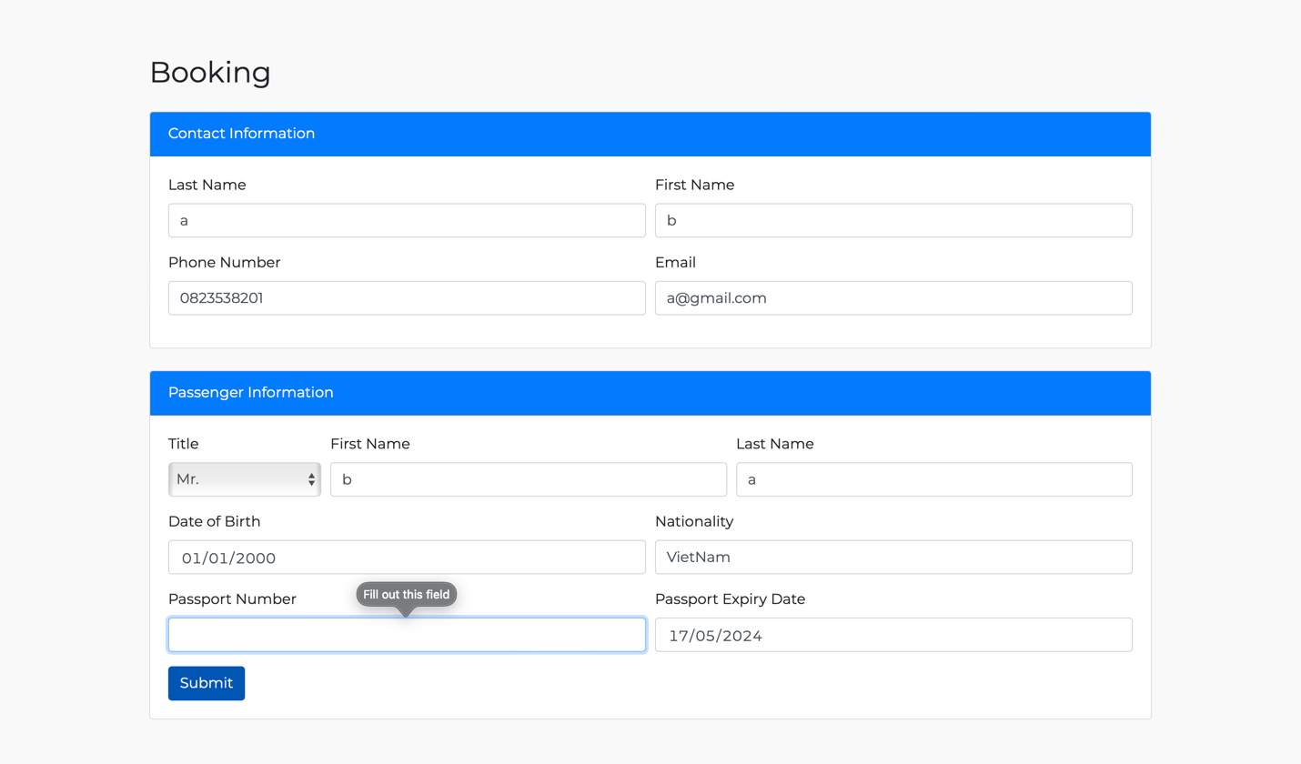
- Error lack of information.
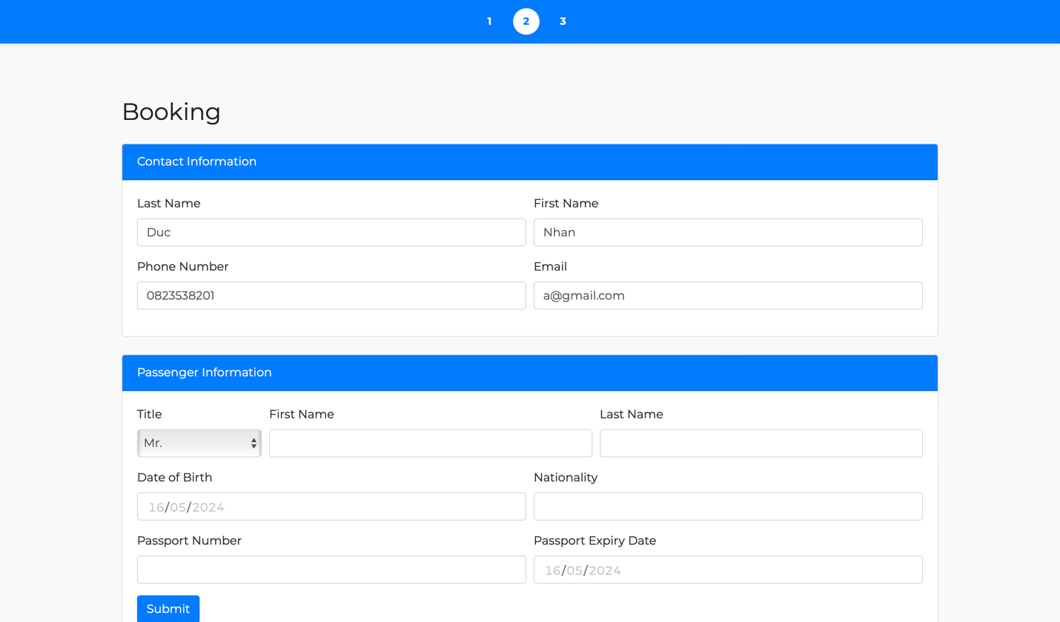
- When you log in first, at booking page contact information will be auto fill out with information of your account.

5.4 Payment Screen:
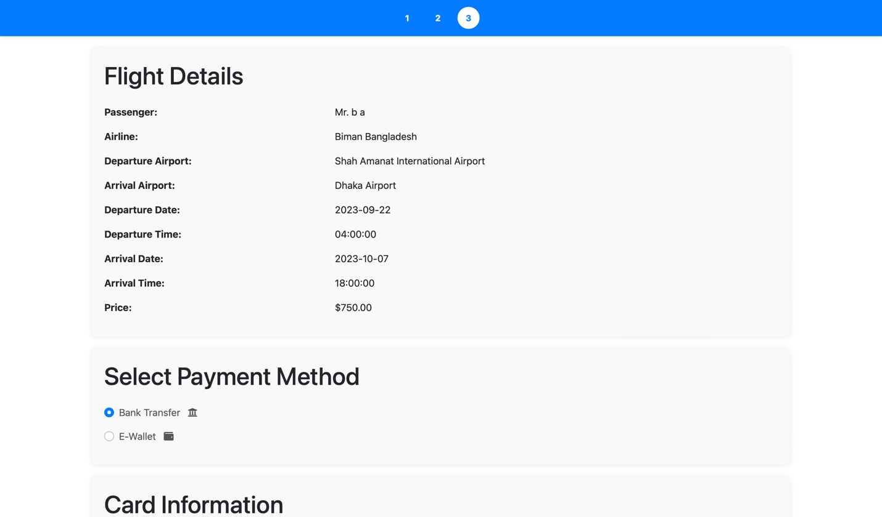
- Payment page.
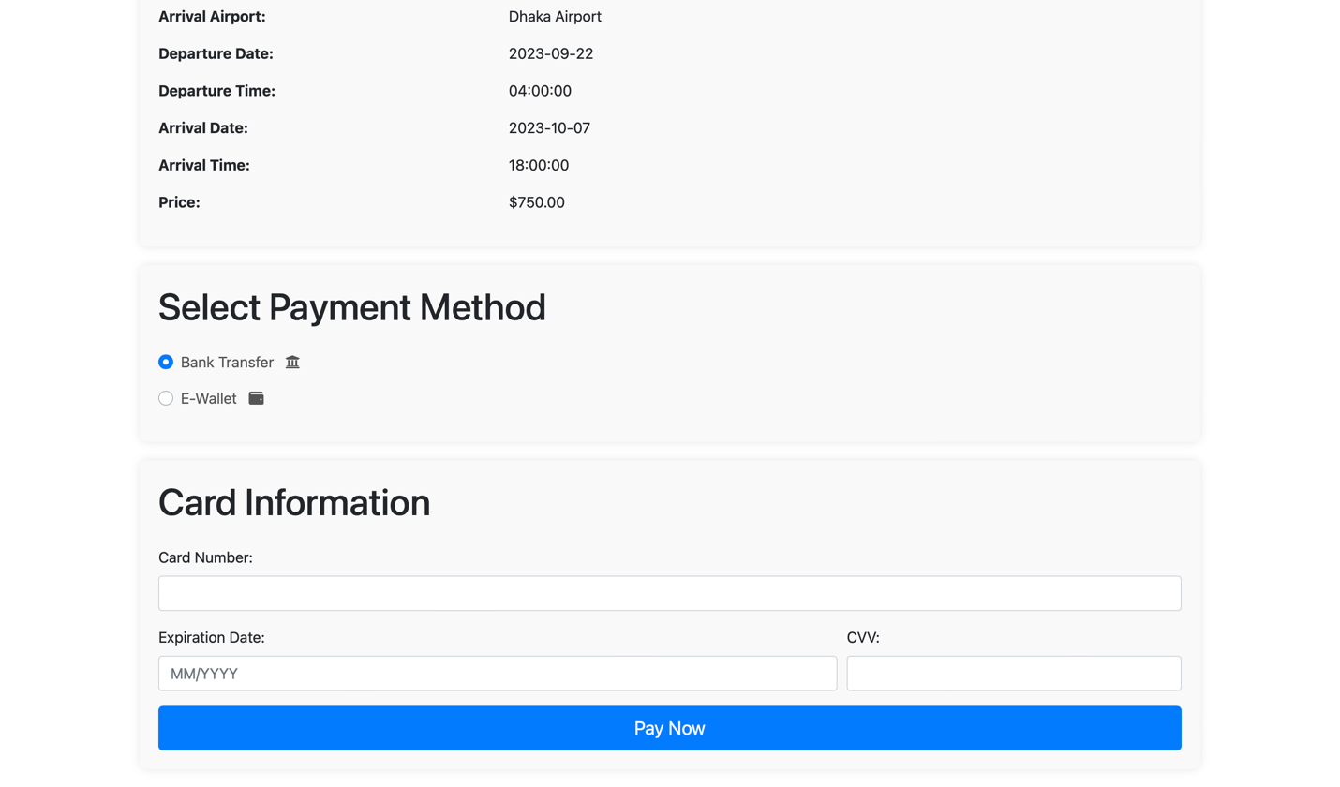
- There are two methods: Bank Transfer or E-Wallet.
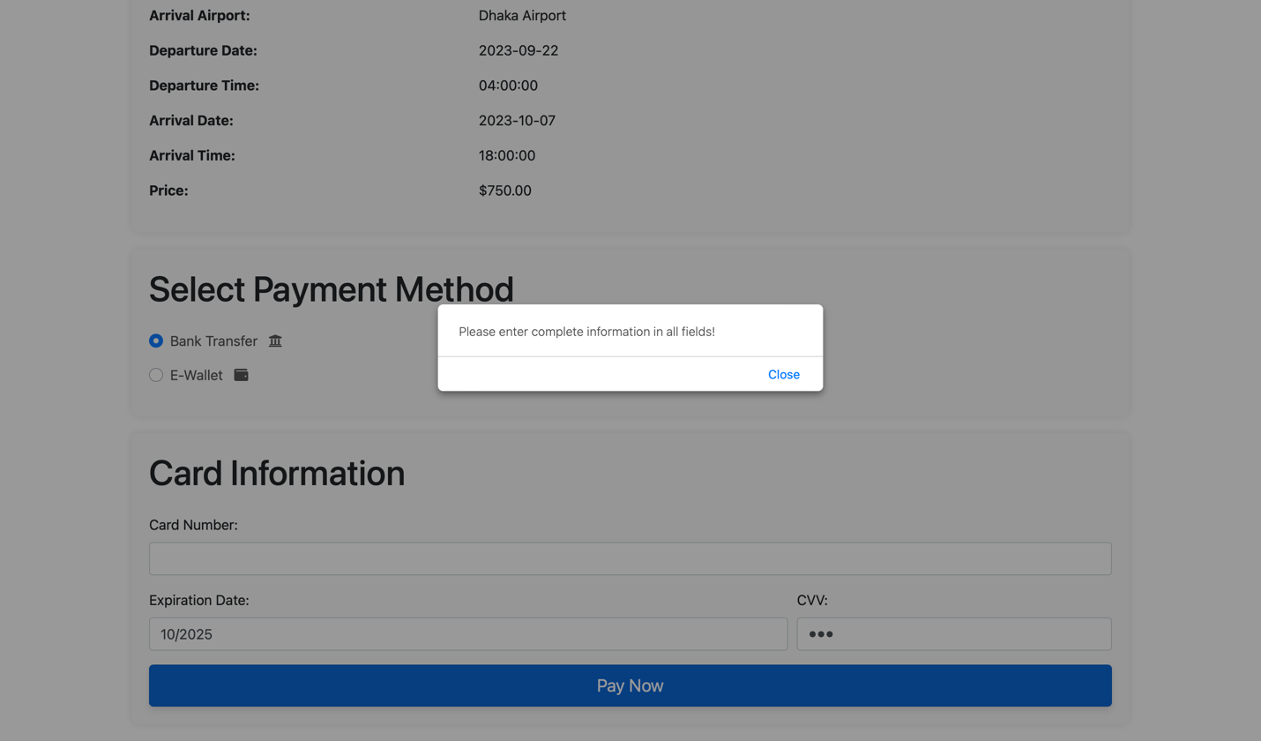
- Bank Transfer error lack of information.
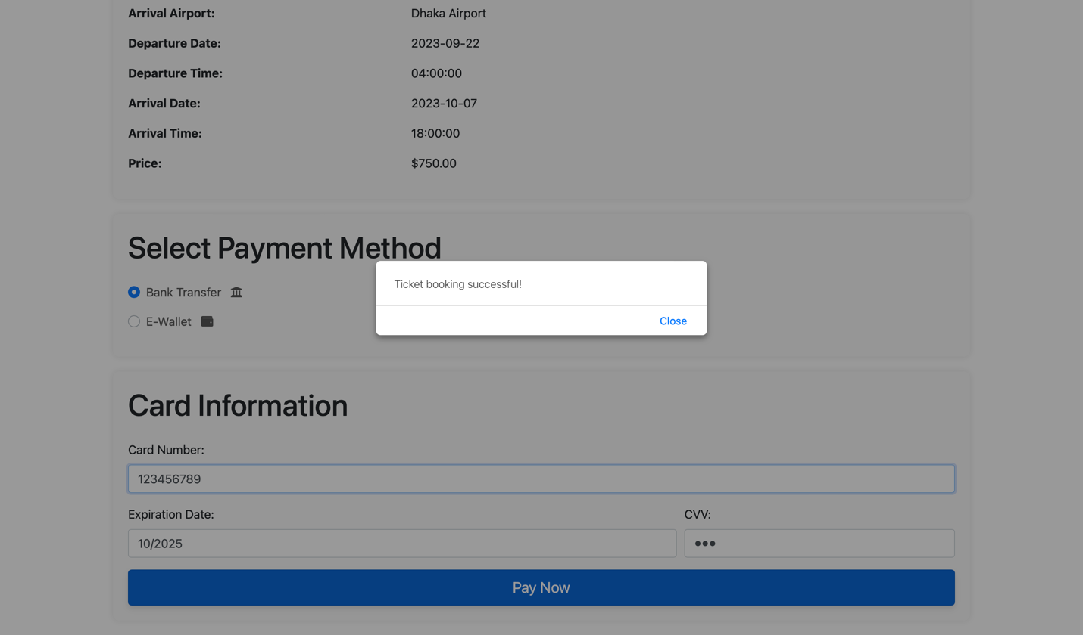
- Purchased successfully!
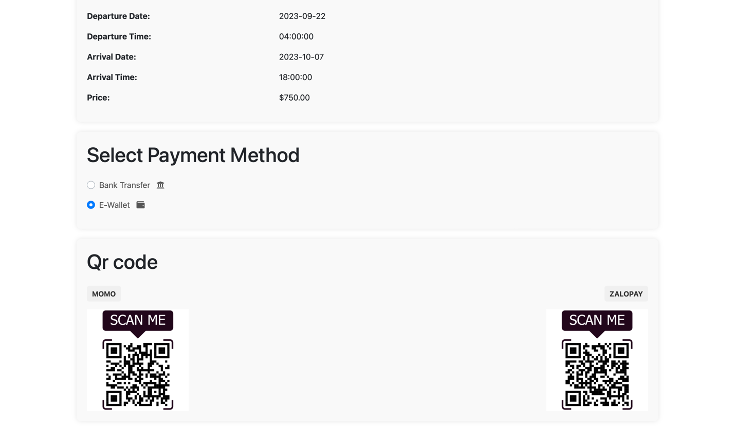
- E-Wallet method.

5.5 Account Screen:
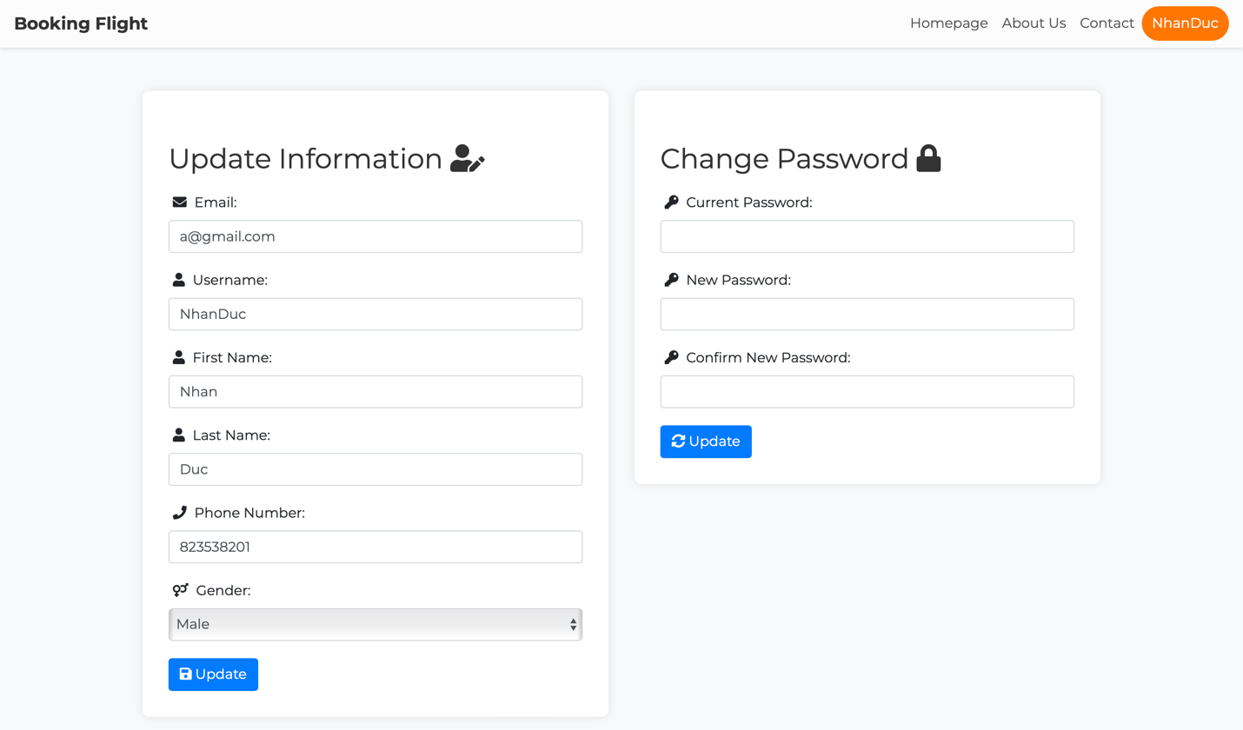
- Account page with ability to change information and password.
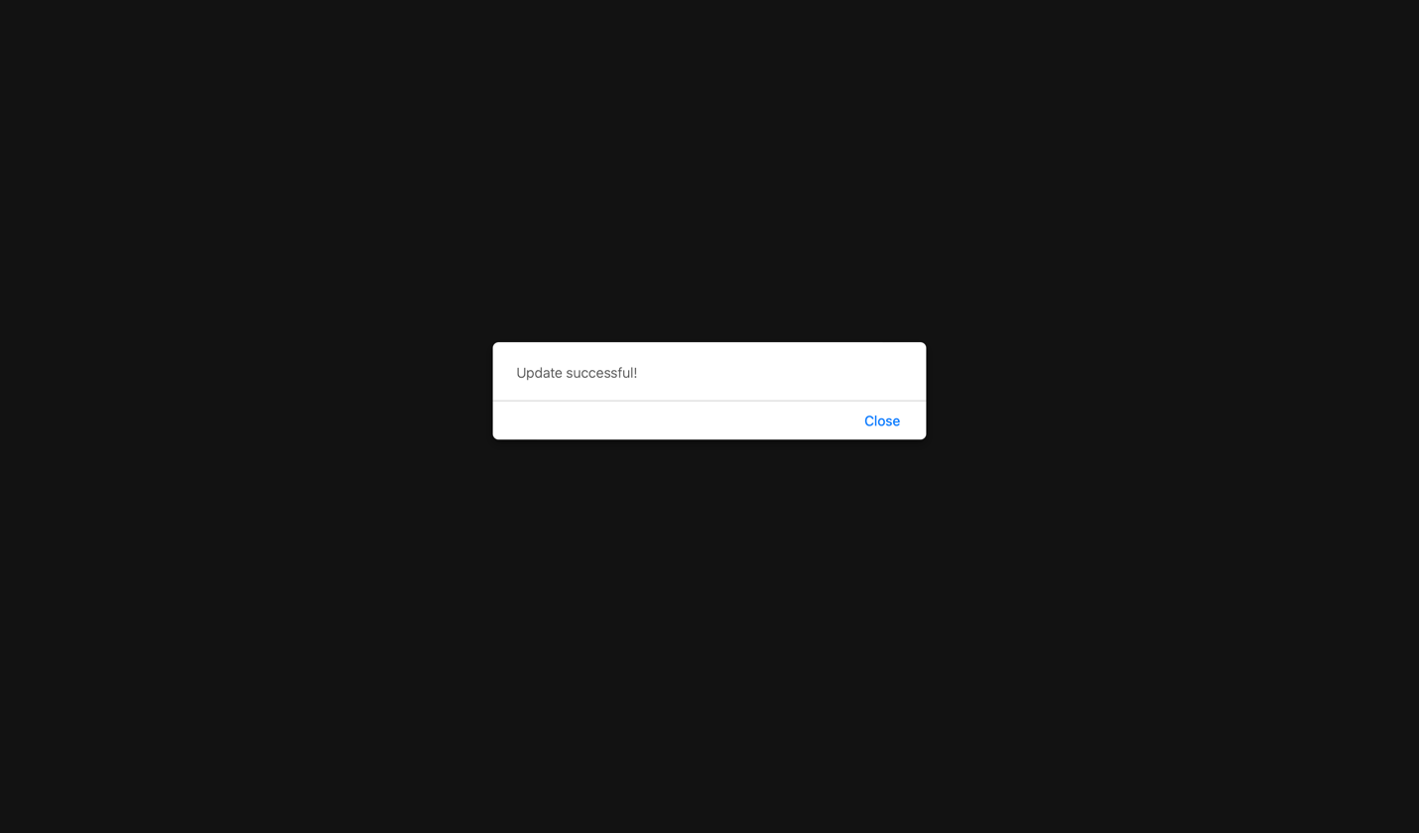
- After change, the screen display successfully!

5.6 Booking History Screen:
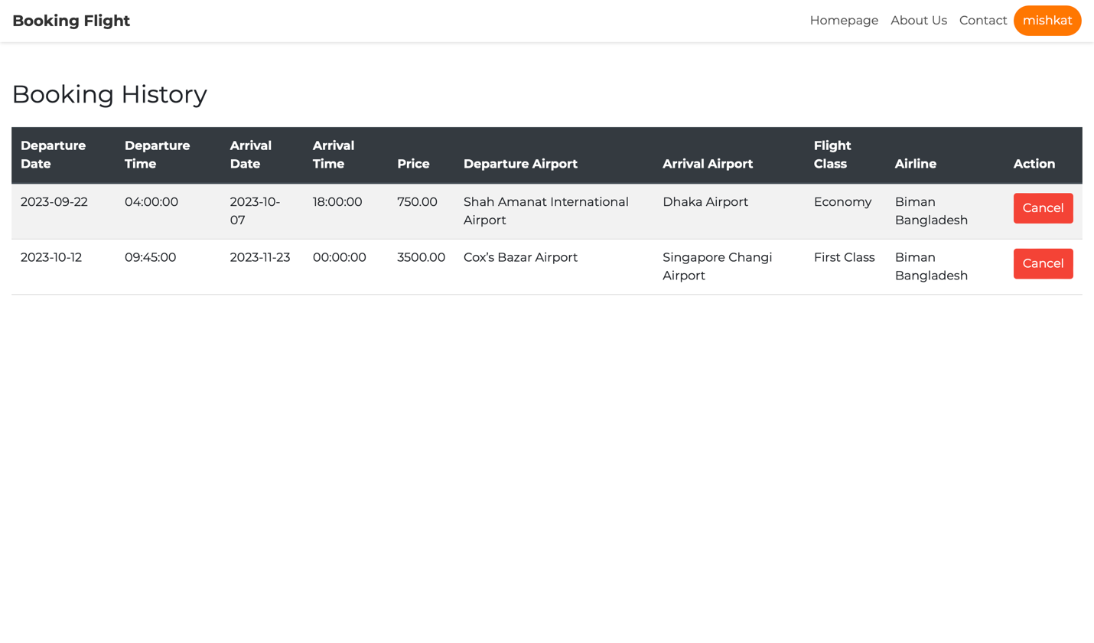
- When you log in, you can access to booked flight page to view and ability to get refund after send canceling request to admin for approve.
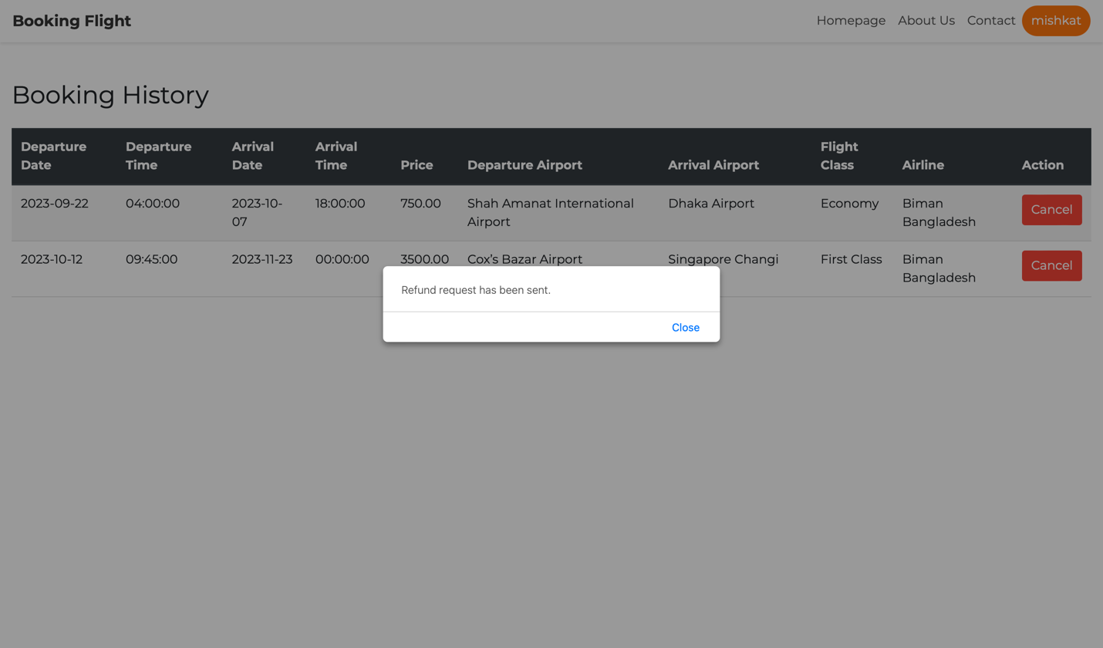
- The screen display “Refund request has been sent” when you decide to cancel.

5.7 Admin Screen:
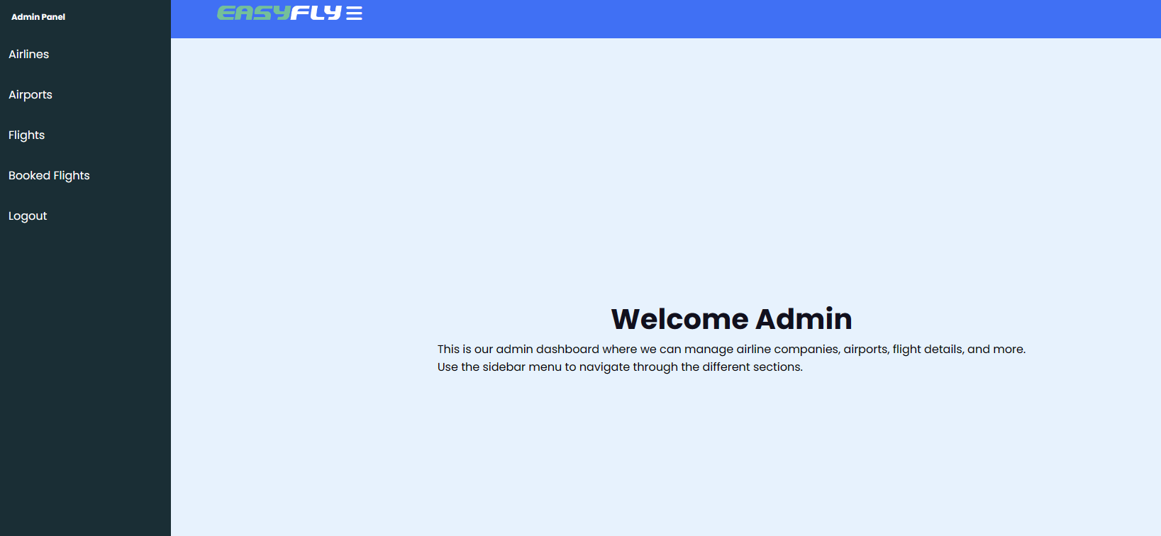
- Admin’s homepage.
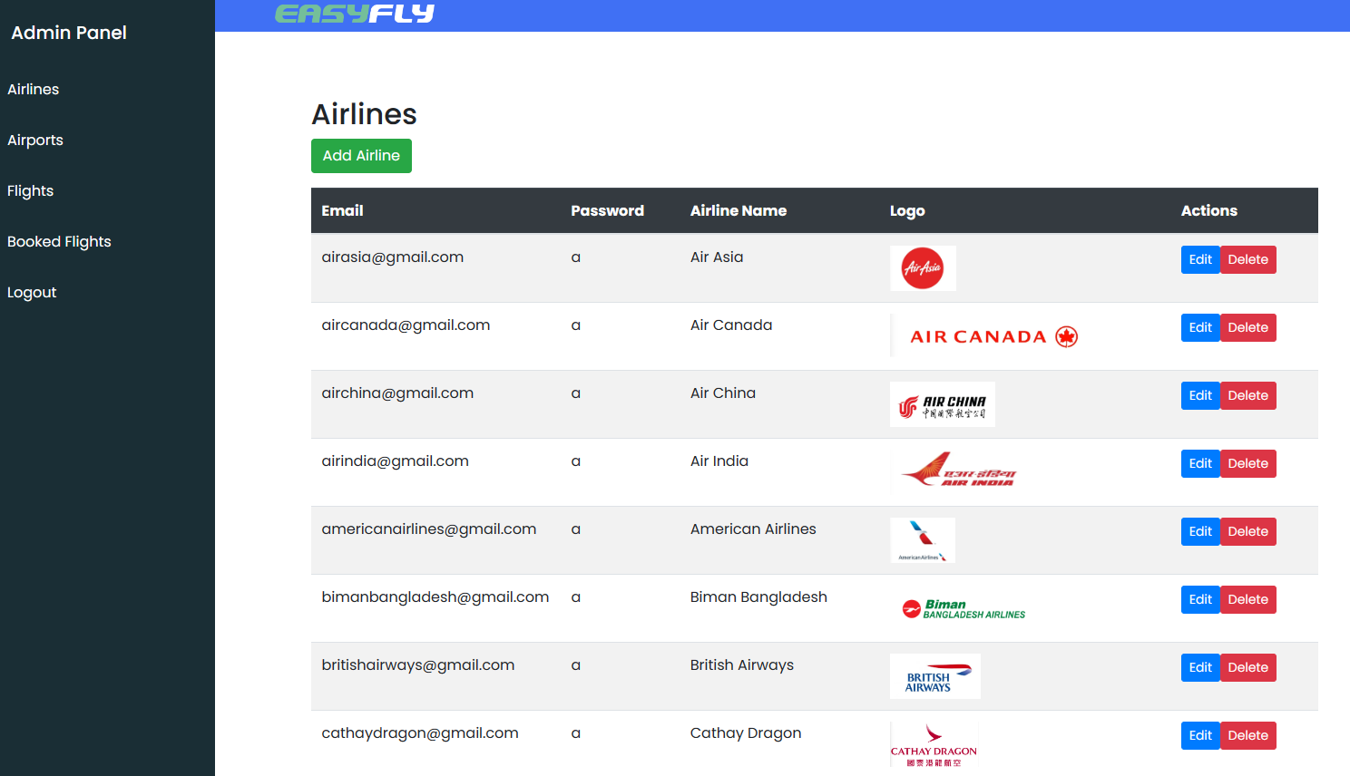
- Admin manage Airlines that show all Airlines with Add, Edit, Delete function.

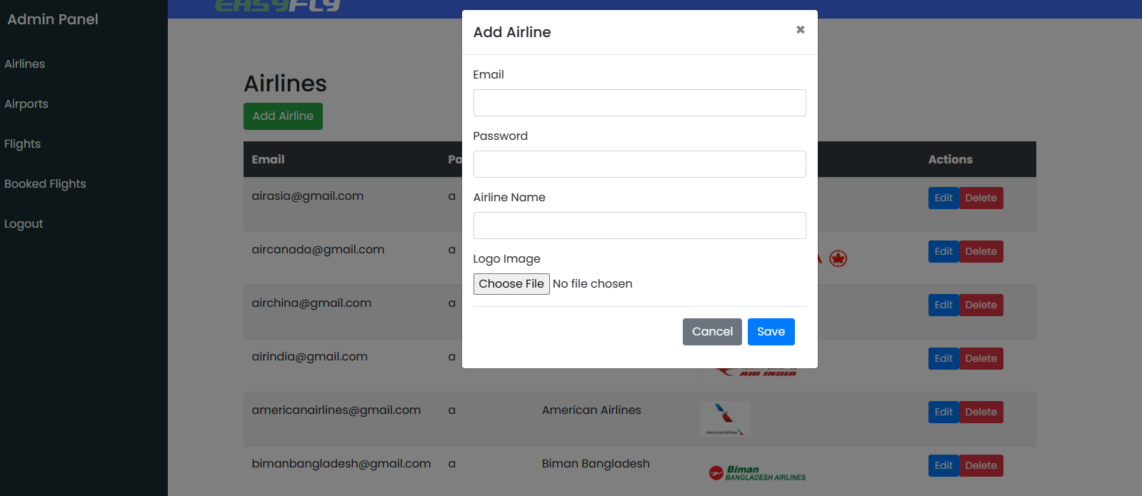
- Add Airline page.
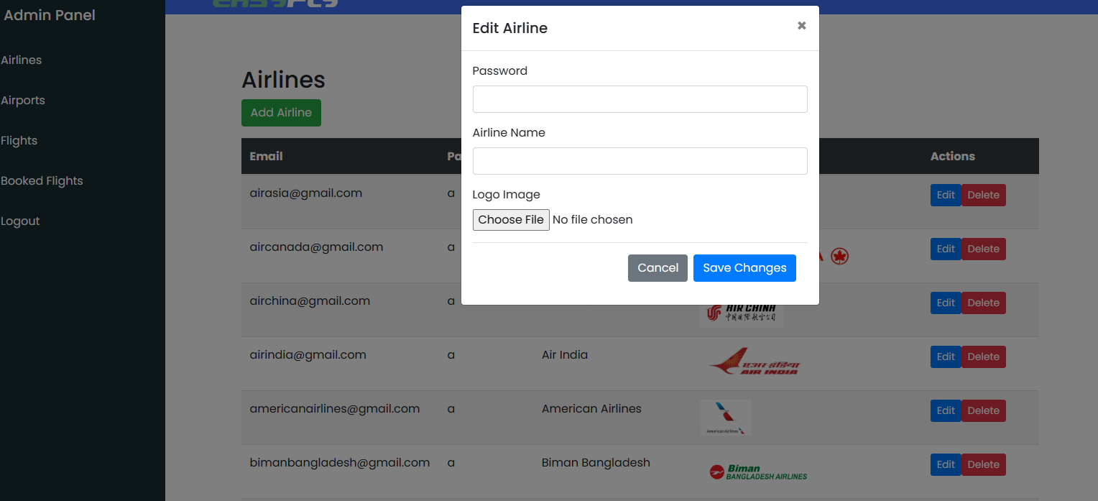
- Edit Airline page.

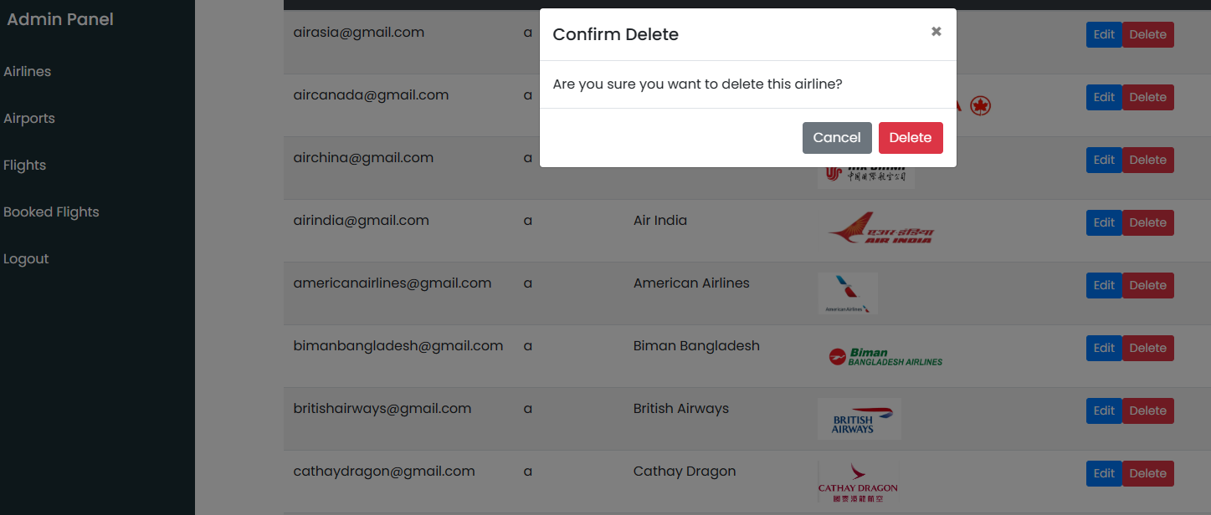
- Confirm delete airline.
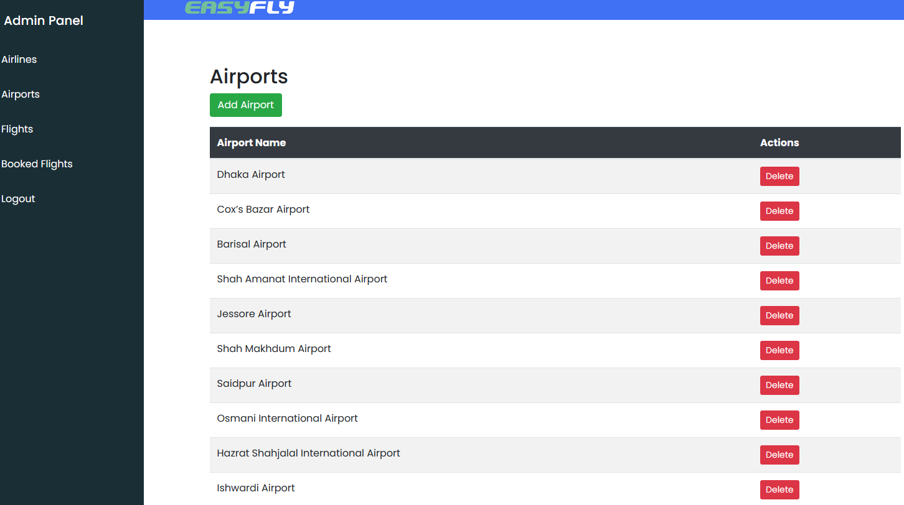
- Admin manage Airports that show Airports with Add and Delete function.

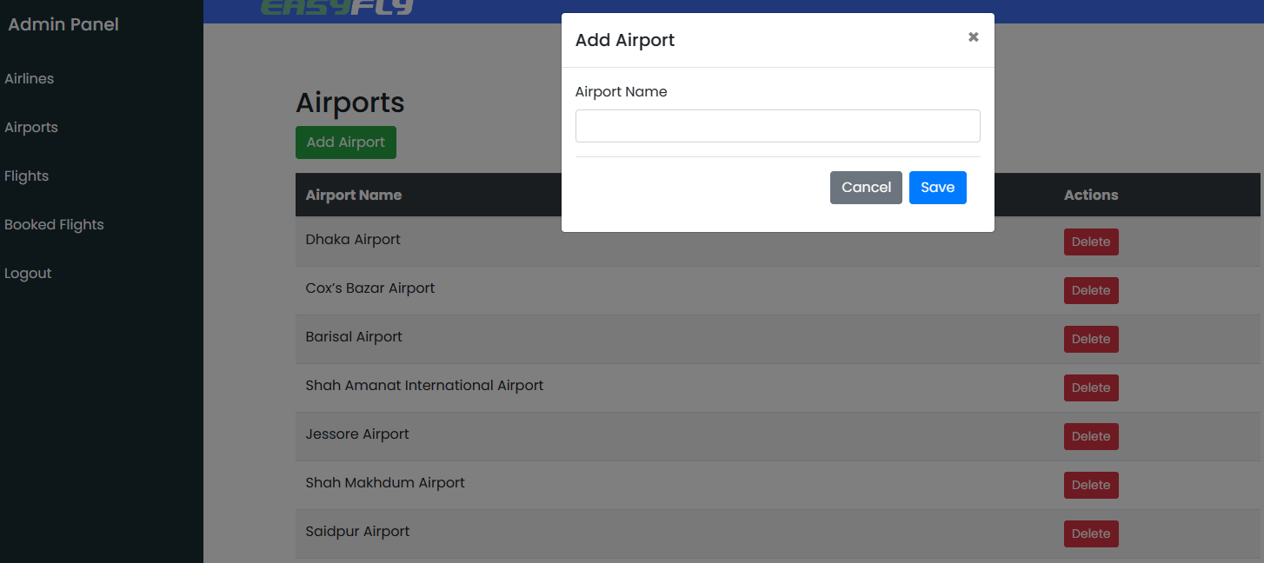
- Add Airport page.
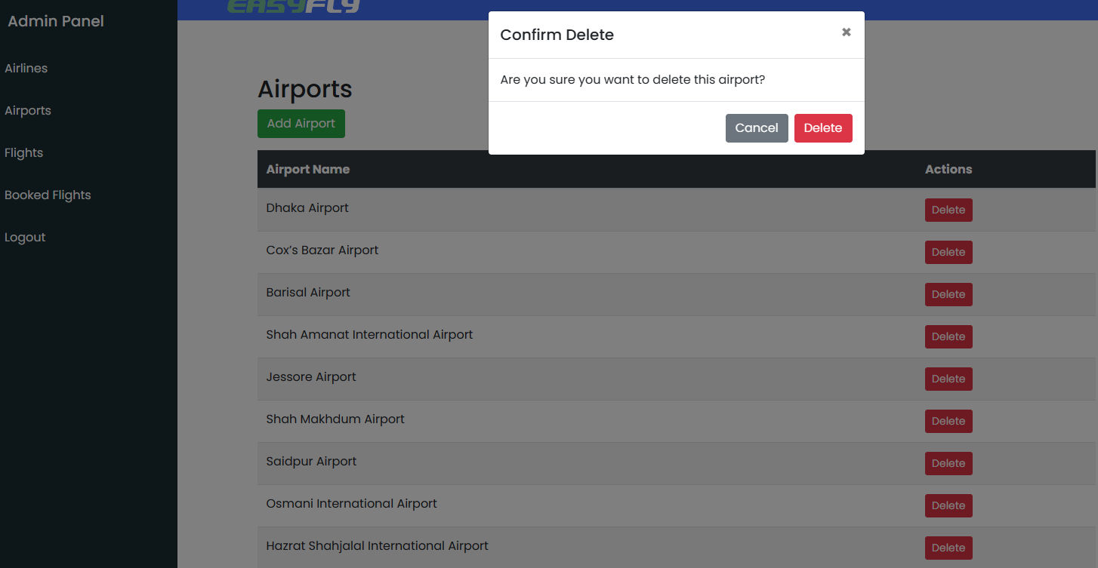
- Confirm Delete Airport page.

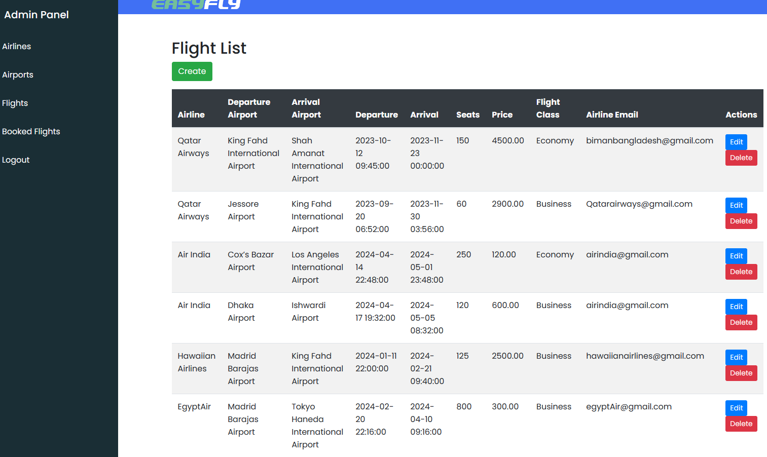
- Admin manage Flights that show Flights with Add, Edit and Delete function.
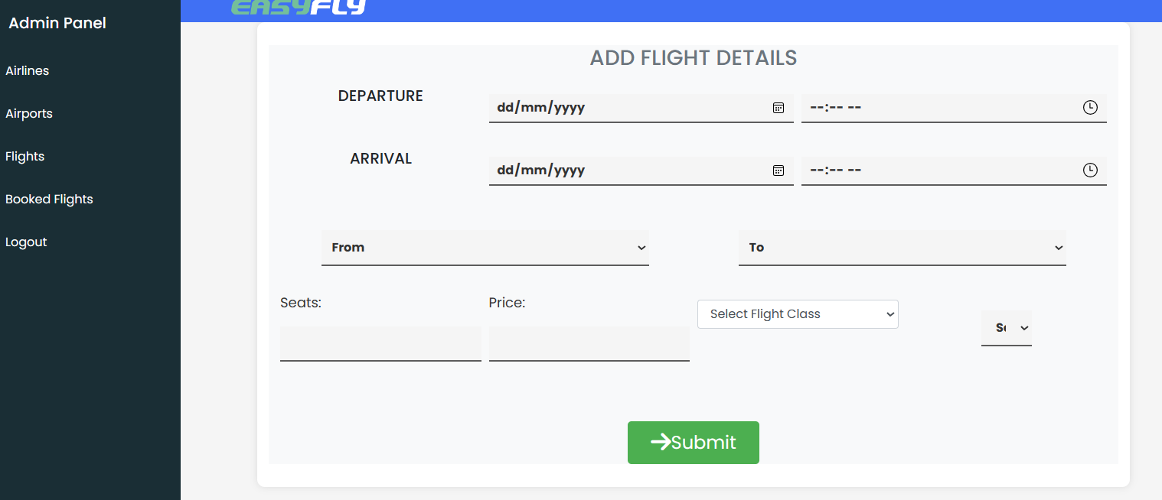
- Admin’s add flight with form for user to input.

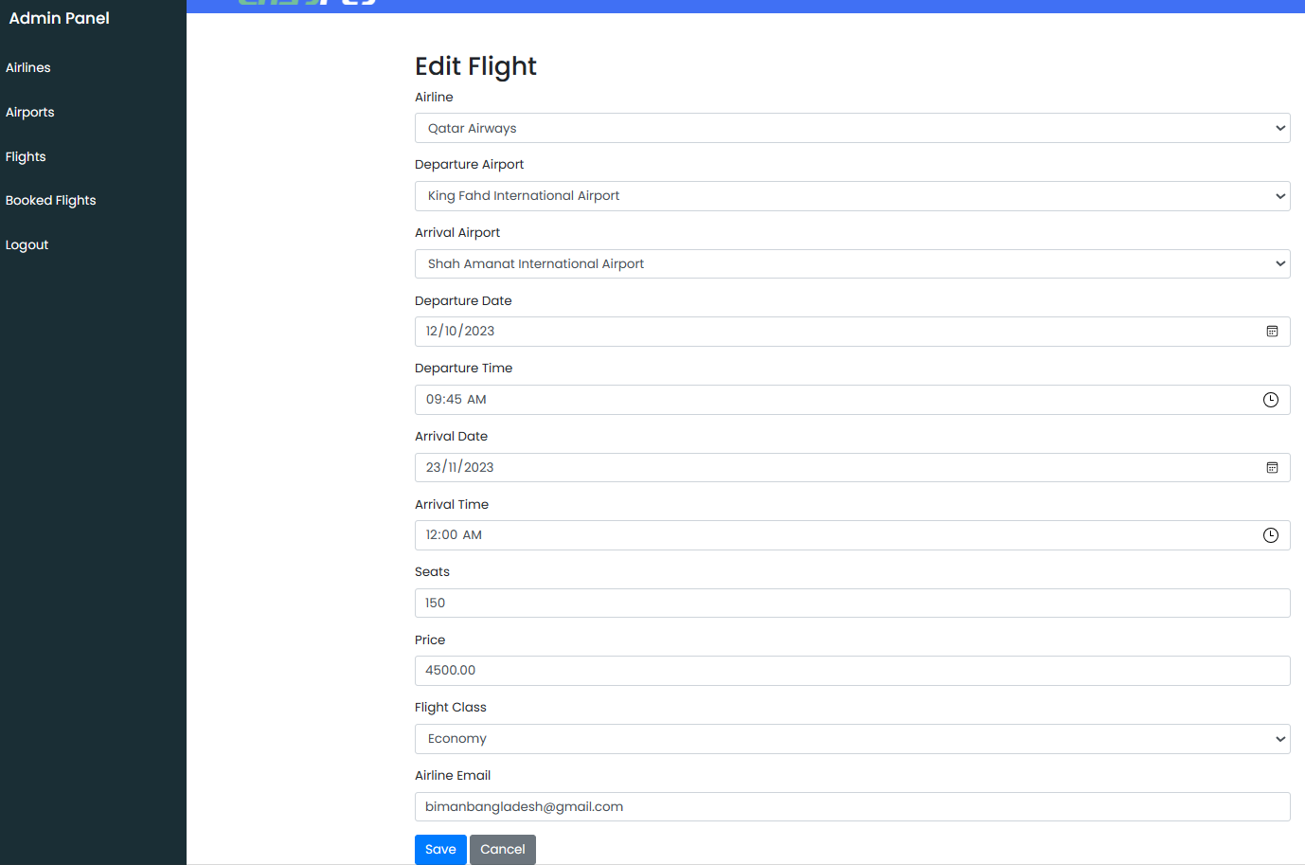
- Admin’s edit flight with form for user to input.
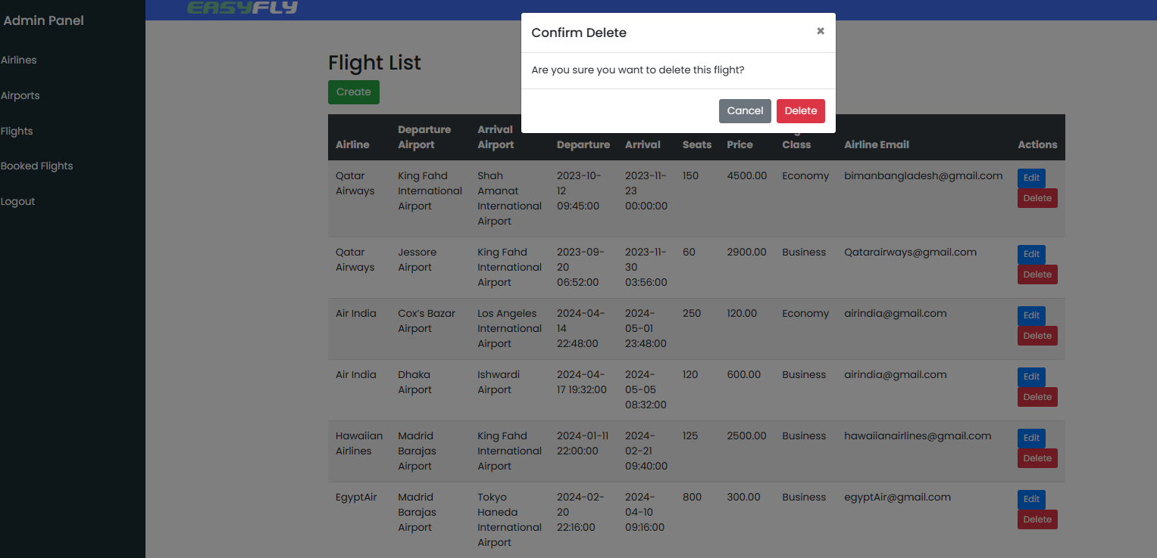
- Confirm delete flight.

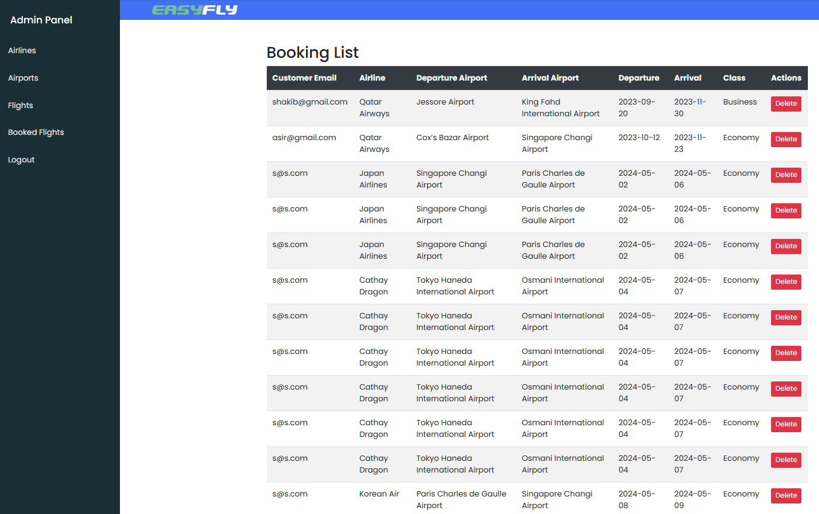
- Booked flights page to show Admin know which flight had been booked and customer that booked it.
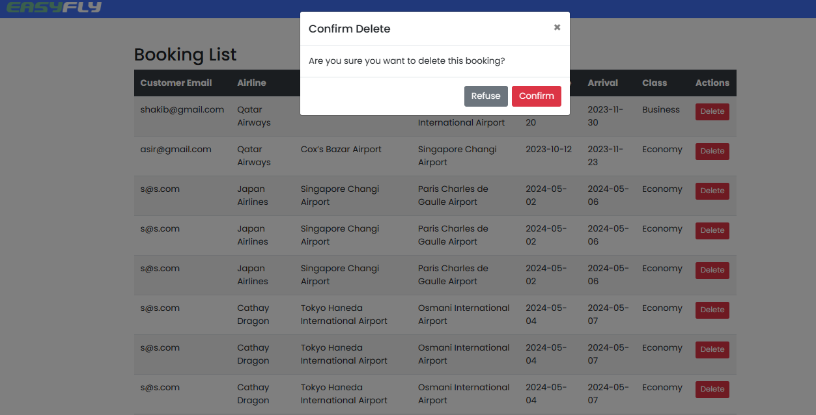
- Confirm delete booked flight page.

